The

CALL BOOK

for MATCH RACING

for 2017 – 2020

Updated for 2020

World Sailing
December 2019

As the leading authority for the sport, World Sailing promotes and supports the protection of the environment in all sailing competition and related activities throughout the world.

Contact details for the World Sailing Executive Office:

Ariadne House
Town Quay
Southampton
Hampshire SO14 2AQ
UK

Tel +44 (0) 2380 635111
Fax +44 (0) 2380 635789
Email office@sailing.org

sailing.org

First edition: January 1992
Second edition: May 1993
Third edition: November 1995
Fourth edition: April 1998
Fifth edition: March 2001
Sixth edition: November 2004
Seventh edition: November 2008
Eighth edition: November 2012 + updates
Ninth edition: December 2016 + updates in December 2018 and December 2019

Published by World Sailing (UK) Limited, Southampton, UK
© World Sailing Limited
All rights reserved
Foreword

Match Racing has continued to develop as an important part of our sport. It is conducted extensively from the Club level through to the highest levels of competition, including the America’s Cup.

The Call Book has been developed and refined since 1992 and is now in its Ninth Edition. The calls have been developed with the input from sailors and umpires alike due to the need for as much consistency as possible in responding to on-the-water protests and other situations that may arise. The aim of the Call Book is to help resolve any doubt amongst sailors and umpires about situations referred to in the Call Book.

The Call Book is structured with calls categorized into easy to follow sections. This makes the Call Book a lot easier to use for people involved in match racing.

The Call Book incorporates changes made in the 2017-2020 Racing Rules of Sailing.

In drafting the calls, care has been exercised to minimise the difference between Fleet Racing and Match Racing in terms of the Right of Way Rules of Part 2, however it is recognized that Match Racing is a separate discipline and that there are some differences from Fleet Racing.

It is important to note that this Call Book, like previous editions, is therefore only authoritative for umpired Match Racing.

I would particularly like to thank the Chairman of the Match & Team Racing Working Party, Marianne Middelthon, for the substantial work that she has undertaken in producing this edition of the Call Book.

The World Sailing Racing Rules Committee trusts that competitors and umpires will continue to provide input to the Racing Rules Committee for further development of the Call Book.

Readers with comments and suggestions are invited to send them to World Sailing.

Bernard Bonneau
Chairman
World Sailing Racing Rules Committee
December 2016

Preface

I would like to thank those who have helped getting this updated version of the Call Book for Match Racing ready in time for the implementation of the 2017 - 2020 Racing Rules of Sailing. A special thank to Dave Perry for his commitment when contributing throughout the process of updating the Call Book. And thanks to the many sailors and umpires who have commented and made suggestions for improvement to the book.

The structure of this book is similar to that of the Call Book for Team Racing; Calls are entered into different sections based on where they are most likely to happen. For example a typical prestart situation will be entered in Section B - The Prestart, although it may happen anywhere else on the course as well. The book starts with an Introduction Section: General Principles for Umpire Decisions. The book continues with sections as they occur in a race: Prestart, Start, Windward Leg, Windward Mark, The Run, The Leeward Mark and The Finish. Finally there are three special sections: Other Rules, The Umpiring Process and Protests and Penalties. At the end of the book there is a list with cross-references of call names from the 2009-2012 version to this version.

The section names are generally the same as those in the Call Book for Team Racing, except there are no Section F (Reaching) or H (The Gybe Mark).

This book has also been revised to reflect the changes to the Racing Rules of Sailing and not least the major changes to Appendix C. Most of the changes are simply changes to the rules references, but some of the calls have changed significantly. You will find the biggest changes from the 2013 - 2016 version of the Call Book in calls describing situations at marks, and as a result of the deletion of RRS 17. As a direct consequence of the rule changes, the following calls have been deleted: D7, E7, E8, G1, G3, most of G5, G6, G8, J2 Question 2, J3 and M8 Question 2.

The book will be updated each year after the World Sailing Annual Conference to include any new calls, submitted as Rapid Response Calls or other ways submitted, and subsequently approved by the World Sailing Racing Rules Committee. These calls will be added into the relevant sections.

Diagrams are limited to 2-dimentional snapshots of each incident. They cannot show the wind strength, the waves, the heel and speed of boats and all the many other things that contribute to a real-life scenario. They should therefore not be used too literally, but rather as a tool to help recognise quickly and clearly the situation being addressed.

At the back of the book there is a list of rules in Call Titles.

The publishing of the Call Book is governed by World Sailing regulation 28. This means that it is authoritative for umpired match racing only. It also means that changes can only be made through the same submission procedures as changes to the rules themselves.

However, World Sailing regulation 28 also provides for the system with Rapid Response Match Racing Calls. Calls proposed under this system should be presented in a format similar to existing calls, and sent to the World Sailing office in Southampton. Any diagrams should preferably be in TSS or Boats. (Both special boat drawing programs.) A call approved as a Rapid Response Call will be immediately communicated to all IU's and MNA's. It will also be posted on the World Sailing website sailing.org.

The Match & Team Racing Rules Working Party will make recommendations on submitted calls and approved Rapid Response Calls to the Racing Rules Committee November meeting each year.

I welcome any comments for improvement of the Call Book.

Marianne Middelthon, Chairman
Match & Team Racing Rules Working Party
INDEX TO CALL BOOK

Section Topic
Introduction General Principles for Umpire Decisions
A Definitions and Fundamentals
B The Prestart
C The Start
D The Windward Leg
E The Windward Mark
G The Run
J The Leeward Mark
K The Finish
L Other Rules
M The Umpiring Process
N Protests and Penalties
Index of Rules (in Call Titles)
List of Old Call Names vs New Call Names

Notes on the text
- Unless otherwise indicated, the wind is blowing from the top of the diagram.
- The phrase ‘a downwind course’ has been replaced by ‘a course that is more than ninety degrees from the true wind’ in the rulebook (see rule C7.2(a)(2)). The Call Book has been changed to use this phrase.
- Any call involving contact will also involve rule 14. However, as explained in the General Principles for Umpire Decisions, rule 14 has no impact on the immediate umpire decision and is therefore not addressed in each separate call.
GENERAL PRINCIPLES FOR UMPIRE DECISIONS
Four general principles apply to umpire decisions:

1. 'Last Point of Certainty'

There are many occasions when umpires are required to judge the exact moment when the state of a boat, or her relationship with another boat, changes. Examples are: passing head to wind, establishing an overlap, approaching the line to start, etc.

In such cases the umpires will apply rule 8, Last Point of Certainty (rule C2.5) and assume that the state of a boat, or her relationship to another boat, has not changed until they are certain that it has changed. For example, a boat is not judged ‘beyond head to wind’ until the umpires are certain that she is so.

2. Disagreement between Umpires

Disagreement or doubt about the facts in a situation may be resolved by applying rule 8, Last Point of Certainty (rule C2.5).

In many situations the ‘Yellow’ umpire has the responsibility to observe ‘Yellow’, while the ‘Blue’ umpire is observing ‘Blue’. In these circumstances additional weight will be given to the observations of the appropriate umpire. When disagreement or doubt remains, and there has been no contact between the boats, the umpires will display the green and white flag. However, if there has been contact, the umpires will penalize both boats (twin penalty).

3. Rule 14: Avoiding Contact

When there has been contact there is a possibility that rule 14 has been broken. However, a breach of rule 14 will not affect any decision made by the umpires in response to a Y-flag.

When the umpires decide that a boat required to keep clear or to give room or mark-room is to be penalized for breaking another rule of Part 2, a breach of rule 14 does not result in an additional penalty under C6.5. When a right-of-way boat or a boat entitled to room or mark-room breaks rule 14 she will be exonerated if there is no damage or injury. If there is damage or injury, this is subject to protest under C 6.1.

However, the umpires will initiate a check for damage to be carried out immediately after finishing. If damage is found, the umpires may impose a penalty under rule C8.6 or, if a penalty of more than one point is appropriate, act under rule C8.4 to inform the protest committee.
4. Definition: Room, and meaning of 'in a seamanlike way'

World Sailing Case 21 states that ‘extraordinary’ and ‘abnormal’ manoeuvres are unseamanlike.

However, actions that are not seamanlike in a fleet of many boats may be considered seamanlike in a situation with only two boats. Thus, in match racing some manoeuvres might be considered normal that would be considered abnormal in other racing, and therefore ‘seamanlike way’ will be interpreted somewhat more broadly in match racing.

Any manoeuvre, however, that puts a boat or her crew at unreasonable risk of damage or injury is unseamanlike. The umpires will judge each incident on the basis of the boat's actions in relation to the conditions of wind and water that she is experiencing.
MR CALL A1

Rule 11 On the Same Tack, Overlapped
Rule 16.1 Changing Course
Definitions Keep Clear

Question 1

Yellow and Blue are sailing parallel courses. Blue has adequate room to move away but nevertheless maintains a parallel course. After about 10 seconds Yellow luffs slowly and from the moment the luff starts, there is no longer any means of Blue avoiding Yellow. Blue luffs and there is contact. There is a Y-flag. What should the call be?
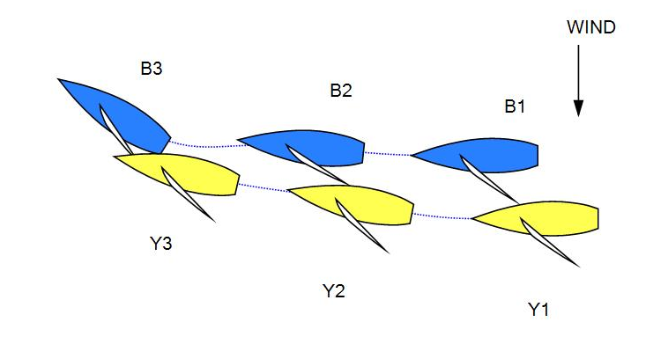
Answer 1

Penalize Blue. When Blue has had an opportunity to keep clear but then sails so close to Yellow that any luff by Yellow will result in contact, Blue fails to keep clear and breaks rule 11.

Question 2

Would the answer be different if Blue came down, or Yellow sailed a slightly higher course thereby causing the separation between the boats to decrease?

Answer 2

No.

MR CALL A2

Rules 10 On Opposite Tacks
Rules 16.1 Changing Course

Question 1
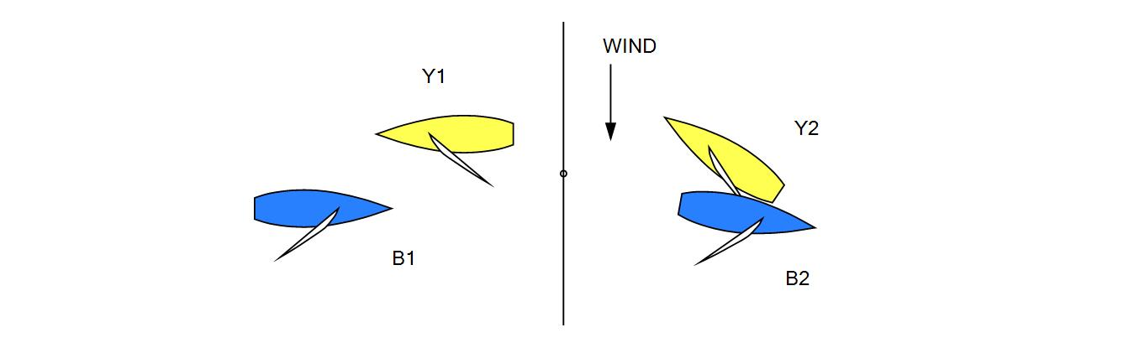
Yellow and Blue approach each other. As they pass, Blue is keeping clear to leeward. Yellow luffs and as a result Blue is unable to respond to keep clear. The stern of Yellow makes contact with the port side of Blue. There is a Y-flag. What should the call be?
Answer 1
Penalize Yellow. Yellow breaks rule 16.1 by changing course without giving Blue room to keep clear.

Question 2
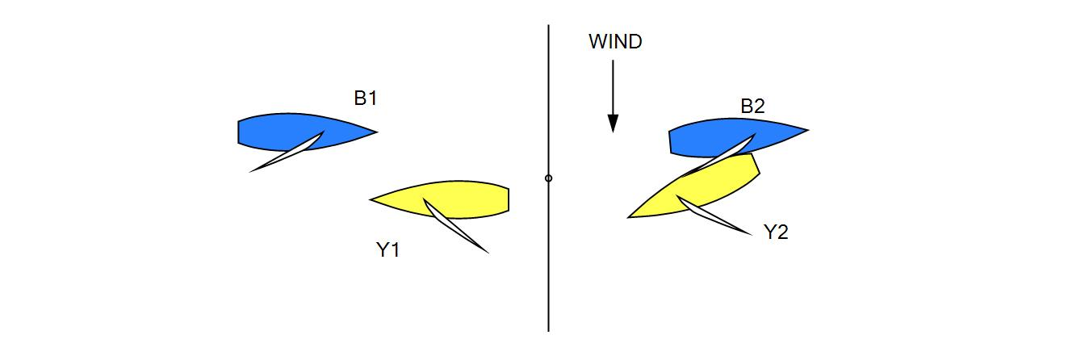
Yellow and Blue approach each other. As they pass, Blue is keeping clear to windward. Yellow bears away. Blue is unable to respond and there is contact. There is a Y-flag. What should the call be?

Answer 2
Penalize Yellow. Yellow breaks rule 16.1 by changing course without giving Blue room to keep clear.

MR CALL A3

Rule 11 On the Same Tack, Overlapped
Rule 18.2 Giving Mark-Room (C2.9)
Rule 21 Exoneration

Question 1

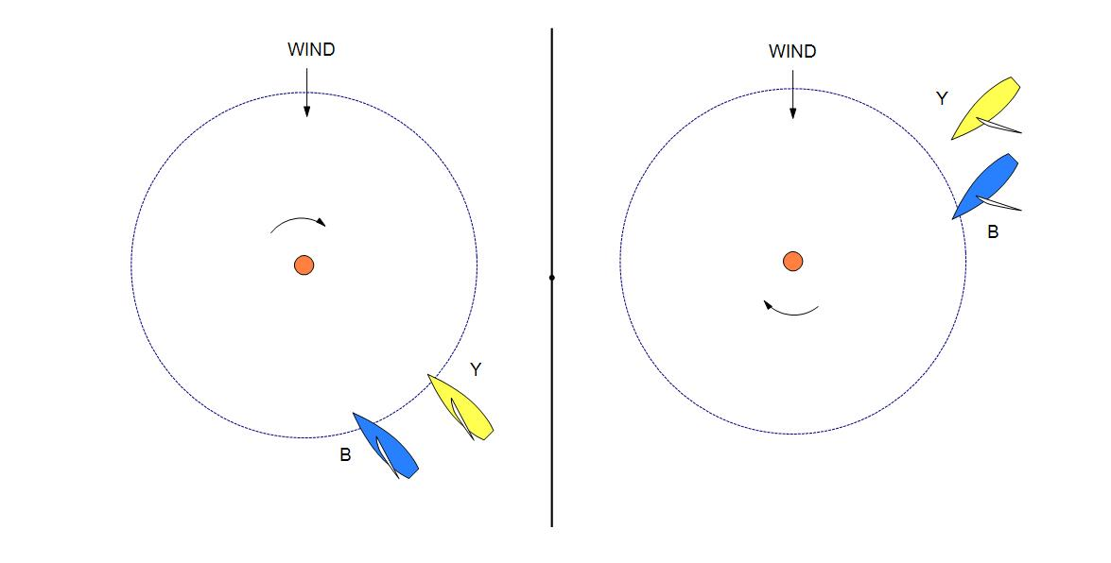
Blue and Yellow are approaching a mark to be left to starboard. What is the latest time Blue may luff?

Answer 1

Rule 18 begins to apply when any part of the hull of either boat is in the zone. From this moment, if Blue luffs and thereafter has to bear away in order to give Yellow mark-room, then Blue breaks rule 18.2. Blue does not break rule 18.2 if she is able to luff while giving mark-room. Yellow is required to keep clear under rule 11. However, she will be exonerated under rule 21(a) if she, while sailing her proper course to round or pass the mark, breaks rule 11 because Blue fails to give her mark-room.

Question 2

If Blue has to bear away to give mark-room, when is she required to do so?

Answer 2

Blue is required to bear away promptly from the moment the first of the boats is in the zone.

MR CALL A4

Definitions Keep Clear and Overlap

Questions

Is a spinnaker pole in ‘normal position’ when the spinnaker is not set but

(i) one end is attached to the mast and the other end is projecting beyond the bow, or

(ii) in the case of an extendable bowsprit-type pole, it is not retracted as fully as it can be

(a) when the spinnaker is, or is being, set up approaching or passing a mark?

(b) when hoisting or lowering the spinnaker?

(c) when beating to windward?

(d) during pre-start manoeuvres?

Answers

The general test when addressing these questions is ‘Is this how the boat would normally be sailed, in the absence of other boats?’ This leads to the following more specific answers:

(a) and (b), for both (i) and (ii):
Yes, if it is the regular practice for the pole to be in that position in the circumstances and the umpires are not of the opinion that the pole had been set up prematurely, or left in position too long, for the purpose of obtaining a tactical advantage (such as the establishment of an artificial overlap).

(c) and (d), for (i);
Yes, if it is the regular practice for that boat to carry her spinnaker pole in that position. It would not be regular practice if, for example, a boat had her spinnaker pole projecting during pre-start manoeuvres but then removed it for starting, or started without the pole projecting then later changed its position so that it was then projecting.

(c) and (d), for (ii): No.

MR CALL A5

Definitions Clear Astern and Clear Ahead; Overlap and Finish (C2.1)

Question 1
At a close downwind finish, Yellow eases her spinnaker halyard, sheet and guy so that the sail is further ahead of her bow than normally. When does she finish? What action should the umpires take?
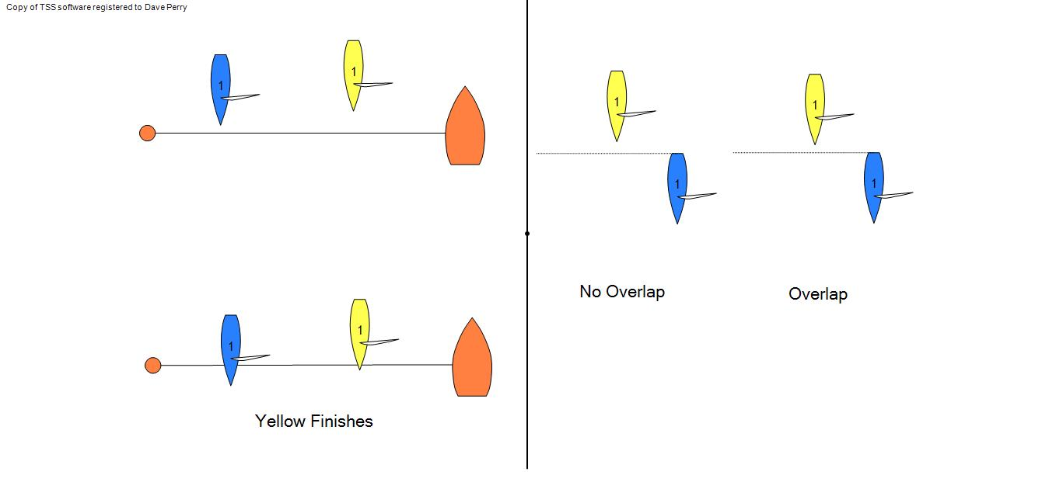
Answer 1
The definition Finish makes it clear that a boat finishes when her hull crosses the finishing line, and the umpires should therefore take no action.

Question 2
Would the situation be different when two boats approach a leeward mark and there is a question about whether they are overlapped?

Answer 2
For the purpose of overlap, a spinnaker in normal position would be taken into account. However, if the umpires see the halyard eased they may judge that it is no longer in normal position and use the hull (or equipment in normal position) to determine whether there is an overlap.

Question 3
Would the answer be different if Yellow was in the process of taking down the spinnaker?

Answer 3
No. A spinnaker in the process of being set or taken down is not ‘equipment in normal position’ in the context of the definition where this term is used.
MR CALL B1

Rule C4.1 Requirements Before the Start
Rule C4.2 Requirements Before the Start

Question 1

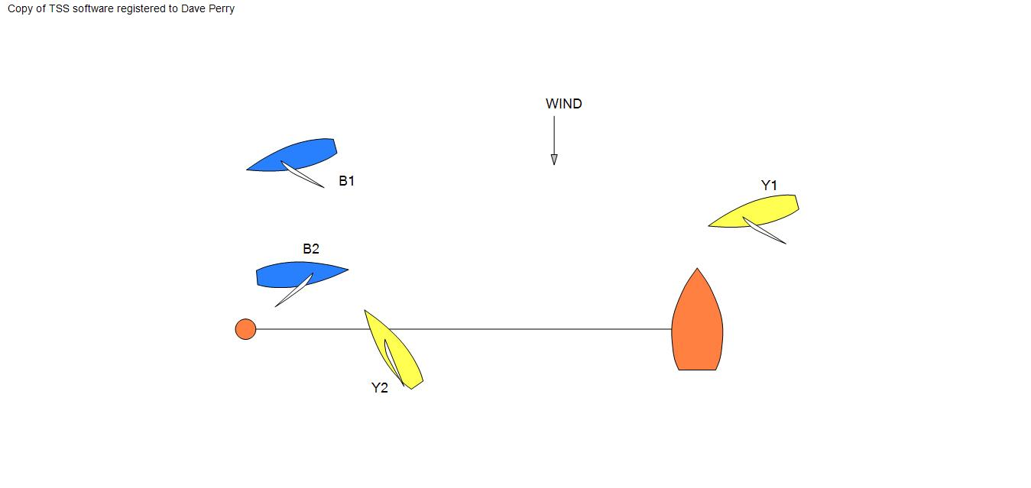
Blue is not outside her assigned end of the starting line at the preparatory signal. As a result Yellow is able to prevent her from crossing the line within the two-minute period. Blue did not cross the line from the course side before starting. What should the umpires do?

Answer 1

Impose two penalties on Blue. One is for breaking rule C4.1, because she was not outside her assigned end; the other is for breaking rule C4.2, because she did not cross the line from the course side within the two-minute period. These rules were broken in two separate incidents, and therefore each requires a penalty.

Question 2

If a boat has not crossed within the two-minute period, is she still obligated to cross before starting?

Answer 2

No. Although she has broken rule C4.2, there is no requirement that she cross the line after the two-minute period has ended.

MR CALL B2

Rule C8.1(a) Penalties Initiated by Umpires: Rule Changes
Rule C9.3 Other Proceedings

Question

The preparatory signal for a match is made before the umpires have arrived in the course area. It is evident to the race committee on the starting line that Yellow has failed to meet a pre-start requirement (rule C4). May the race committee initiate a post-race hearing?

Answer

No. Such a matter is included under rule C9.3 and only the umpires may take action.

Similarly, if the umpires had been present and they had not signalled a penalty, again no further action could be taken.

MR CALL B3

Rule 11 On the Same Tack, Overlapped
Rule 15 Acquiring Right of Way

Question

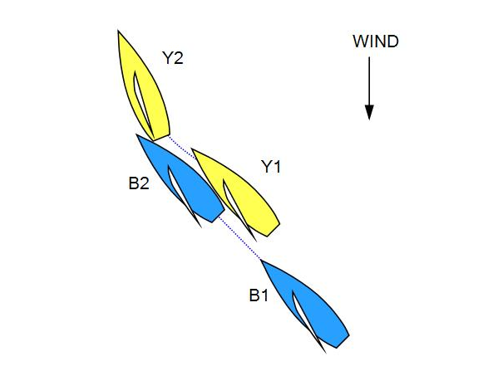
Blue establishes an overlap from clear astern. Yellow luffs immediately, and her stern hits Blue. There is a Y-flag. What should the call be?

Answer

Rule 11 required Yellow to keep clear and rule 15 required Blue to initially give Yellow room to keep clear.

If Yellow luffed so that she did not take unnecessary room (see World Sailing Case 24), then Blue broke rule 15. Penalize Blue.

If Yellow clearly took more room than was necessary, then Yellow broke rule 11. Penalize Yellow.

MR CALL B4

Rule 11 On the Same Tack, Overlapped
Rule 15 Acquiring Right of Way

Question

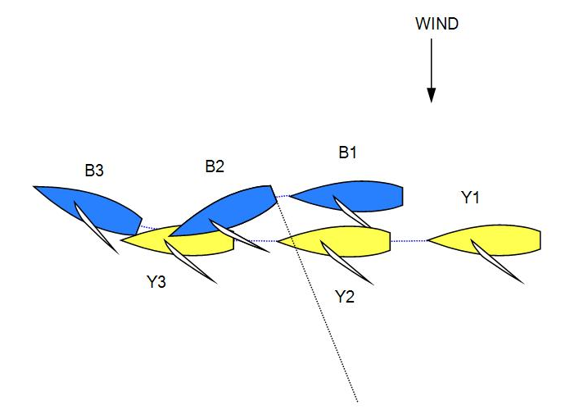
Blue and Yellow are on the same tack, with Blue clear ahead. Yellow is moving faster than Blue. Blue bears away and the boats become overlapped. Blue then turns the other way and there is a collision. There is a Y-flag. What should the call be?

Answer

Penalize Blue. When Blue bears away, Yellow acquires right of way, at least in part, through Blue's actions. Therefore the second part of rule 15 applies, so she does not have to give Blue room to keep clear.
MR CALL B5

Rule 11 On the Same Tack, Overlapped
Rule 16.1 Changing Course

Question

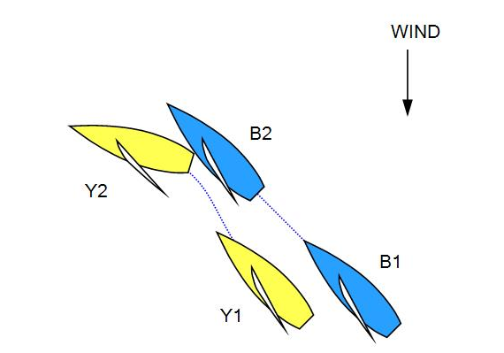
Yellow and Blue are sailing parallel courses. Yellow bears away hard and Blue is unable to keep clear. Contact occurs. There is a Y-flag. What should the call be?

Answer

Penalize Yellow. Yellow is a right-of-way boat changing course. She did not give Blue room to keep clear and therefore broke rule 16.1.

If Yellow had borne away slightly and immediately made contact with Blue, then Blue was not keeping clear under rule 11. Penalize Blue.
MR CALL B6

Rule 11 On the Same Tack, Overlapped
Rule 13 While Tacking or Gybing (C2.6)
Rule 16.1 Changing Course

Question 1

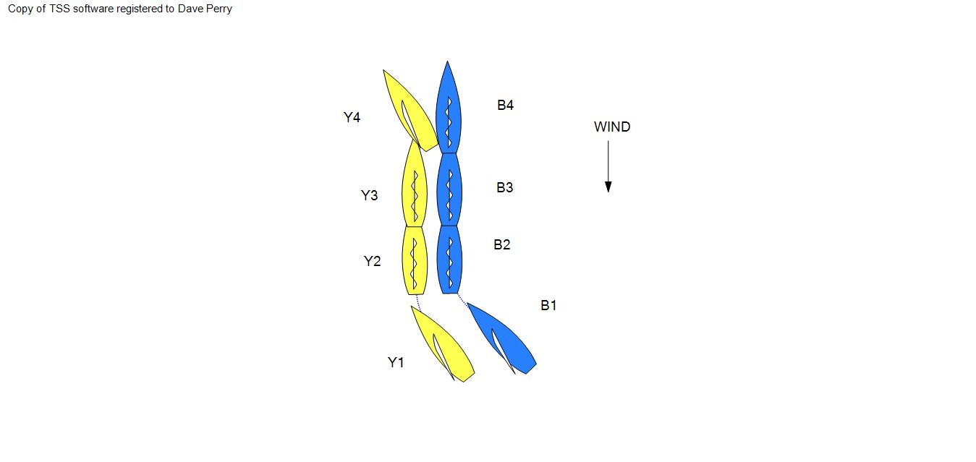
Yellow, a leeward boat, luffs head to wind, and Blue luffs in response, so that both reach positions side by side, head to wind. Blue continues to change course and passes head to wind. In so doing she makes contact with Yellow. There is a Y-flag. What should the call be?

Answer 1

If, when Yellow begins her luff, Blue immediately responds and continues to do what she is able to do to keep clear throughout the incident but there is contact anyway, then Yellow is not giving Blue room to keep clear and she breaks rule 16.1. Penalize Yellow.

If Blue could have kept clear, but either responded too slowly, not enough, or over rotated, then Blue has broken rule 11 or 13.1. Penalize Blue.
Question 2

In similar circumstances, Blue responds and when head to wind, she remains so for a time. Then Yellow bears away and their sterns make contact. There is a Y-flag. What should the call be?

Answer 2

If Yellow's change of course immediately results in contact with Blue, Blue was not keeping clear and broke rule 11. Penalize Blue.

If there was more distance between them, and Yellow bears away hard giving Blue no room to keep clear, then Yellow breaks rule 16.1. Penalize Yellow.

The umpires' decision is based on the distance between the boats, the nature of Yellow's bear-away and the efforts of Blue to keep clear.
Question 3

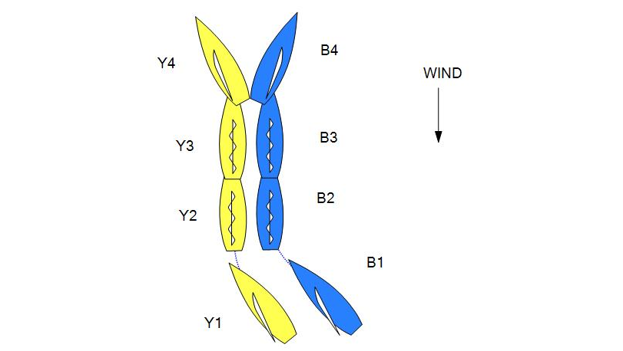
In similar circumstances, Blue keeps clear, but when head to wind, she maintains it for a time. Blue then passes head to wind, and slightly later Yellow bears away and their sterns make contact. There is a Y-flag. What should the call be?

Answer 3

When Blue passes head to wind, the boats are no longer overlapped on the same tack and the second part of the definition of Keep Clear no longer applies.

If the contact would have occurred without Yellow bearing away, Blue broke rule 13.1. Penalize Blue.

If the contact would not have occurred without Yellow's bearing away, Yellow broke rule 16.1. Penalize Yellow.

MR CALL B7

Rule 10 On Opposite Tacks
Rule 16.1 Changing Course
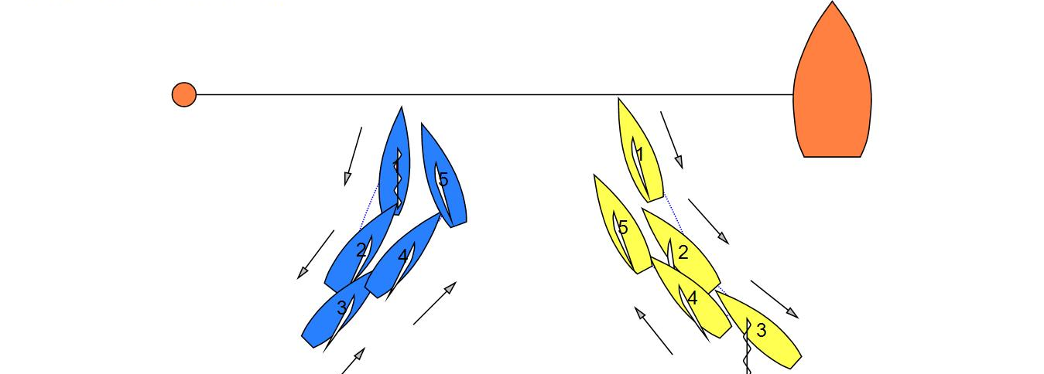

Position 1

Before the start Yellow and Blue are on opposite tacks with both boats head to wind. After some time both begin moving astern.

Position 2

Both reach a close-hauled course, but continue moving astern.

Position 3

Blue begins to move forward on a course to pass in front of Yellow. Yellow continues to move astern.

Position 4

Yellow begins to move forward, and from this moment Blue can no longer pass in front of Yellow. Blue immediately luffs to tack.

Position 5

Blue tacks, but before she reaches close hauled Yellow luffs to avoid contact. There is a Y-flag. What should the call be?

Answer

Display the green and white flag. Although Yellow did not appear to change compass course between positions 2 and 4, she did change course by reversing the direction in which she was travelling (astern to ahead). Rule 16.1 required Yellow to give room to Blue, which she did by luffing at position 5.

MR CALL B8

Rule 12 On the Same Tack, Not Overlapped
Definitions Clear Astern and Clear Ahead; Overlap

Question

In the pre-start, Blue and Yellow are both on the same tack with Yellow clear ahead. Both boats start moving astern and are still not overlapped.

Which boat has the right-of-way?
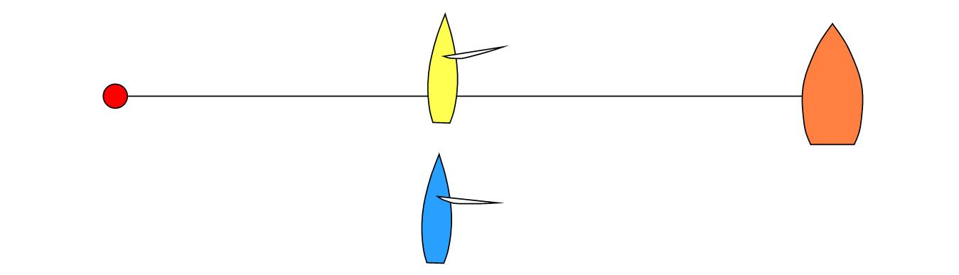
Answer

According to the definition Blue is clear astern and therefore required by rule 12 to keep clear.

Whether one boat is clear astern of another or overlapped with her does not depend on the direction of motion of either boat.

MR CALL B9

Rule 11 On the same Tack, Overlapped
Rule 16.1 Changing Course

Question 1
Initially both boats are stationary on starboard tack, but then start moving astern by backing their mainsails.

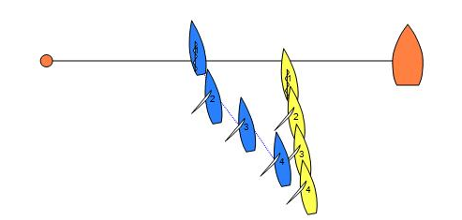
From position 2, Blue pushes harder on her mainsail and at the same time sculls forcefully on the windward side to make the boat move rapidly sideways (crabbing). There is a Y-flag. What should the call be?
Answer 1
Rule 22.3 regarding moving astern or sideways through the water does not apply (see rule C2.11). However, when Blue, the right-of-way boat, begins travelling to windward between position 2 and 3, she is changing course and must give Yellow room to keep clear under rule 16.1.

If, when Blue begins crabbing, Yellow immediately responds and continues to do all she can to keep clear (including crabbing to windward herself) but is unable to keep clear, then Blue is not giving Yellow room to keep clear and breaks rule 16.1. Penalize Blue.

If Yellow could have kept clear, but either responded too slowly or not enough, then Yellow has broken rule 11. Penalize Yellow.

Question 2
Would the answer be different if Blue began crabbing from her stationary position 1?

Answer 2
No
MR CALL B10

Rule 8 Last Point of Certainty (C2.5)
Rule 11 On The Same Tack Overlapped
Rule 14 Avoiding Contact
Rule 16.1 Changing Course
Question
Blue the windward boat bears away hard to pass behind Yellow. Yellow luffs shortly after Blue begins to bear away. Blue keeps clear in position 2.
In Position 3 both boats are passing each other’s windward side. There is contact between the boats. Both boats Y-flag.
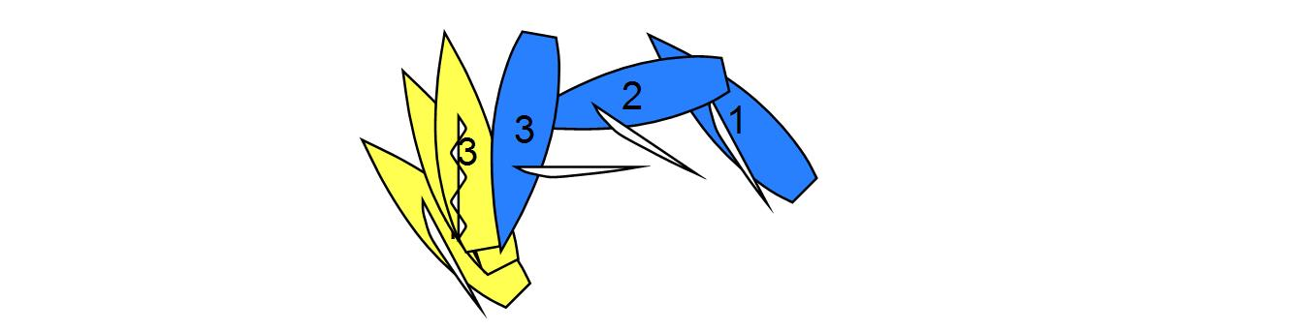
What should the call be?
Answer
Penalize Blue as the keep-clear boat unless Yellow breaks rule 16.1 by changing course without giving Blue room to keep clear.

As stated in rule 8, Last Point of Certainty, the umpires will assume that the state of a boat or its relationship with another has not changed until they are certain that it has changed. The umpires cannot be certain which is the right-of-way boat in position 3. Their last point of certainty was that Yellow was the right-of-way boat.
MR CALL B11

Rule 13 While Tacking or Gybing (C2.6)
Rule 16.1 Changing Course
Rule 21 Exoneration

Question 1
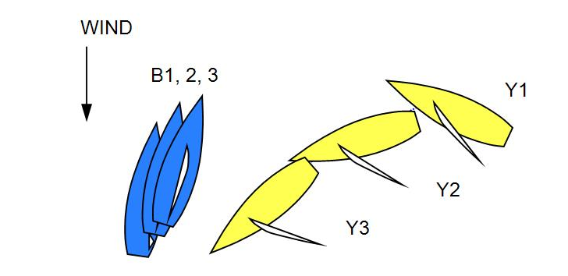
Before the start Yellow and Blue are separated and not on a collision course. Blue intends to tack but after passing head to wind she loses way. Before Blue gets to a close-hauled course, Yellow bears away towards Blue. Blue is unable to take any avoiding action that would prevent a collision if Yellow were to stop bearing away. However, Yellow continues to bear away and passes astern of Blue. There is a Y-flag. What should the call be?

Answer 1
Display the green and white flag. Yellow's change of course required her to give Blue room to keep clear (rule 16.1). Yellow complies with rule 16.1 by bearing away continuously. Blue is sailing within the room to which she is entitled under rule 16.1, and is therefore exonerated under rule 21(a) for her breach of rule 10. The same answer would apply if Blue had succeeded in completing her tack and lost way.

Question 2
Would the answer change if Blue's helmsman had intentionally handled his boat so as to lose steerage and to place it in a situation where it would not be possible to keep clear if Yellow should change to a collision course?

Answer 2
No. No rule prohibits Blue from being in the position she was in here, whether or not she does so deliberately.

MR CALL B12

Rule 10 On Opposite Tacks
Rule 16.1 Changing Course
Rule 19.2 Giving Room at an Obstruction

Question

Before the start Yellow and Blue, reaching on starboard tack, approach an anchored boat. When Yellow is at the obstruction, she is clear ahead of Blue. Yellow passes to windward of it, bears away alongside it, then gybes in order to sail around its stern. Very soon after Yellow gybes, Blue is still on starboard and gains a small inside overlap. Blue changes course trying to avoid contact with Yellow but there is contact. There is a protest. What should the call be?

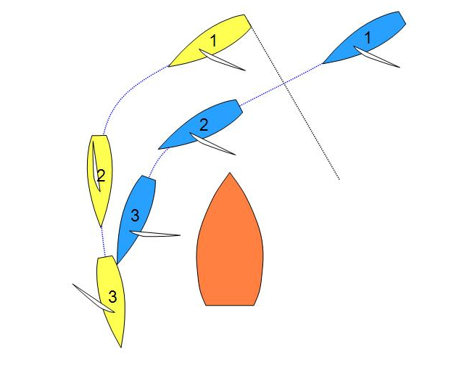
Answer

Blue becomes right-of-way boat the moment the boats become overlapped, or when the foot of the mainsail of Yellow crosses the centreline when she gybes, whichever happens first, Yellow gives up her right-of-way, so rule 15 does not apply. It was possible for Yellow to give room to Blue from the time the overlap was established. Yellow must give room to Blue under rule 19.2(b), and keep clear of Blue under rule 10.

Yellow fails to keep clear of Blue. Penalize Yellow.

MR CALL B13

Rule 19.2 Giving Room at an Obstruction

Question

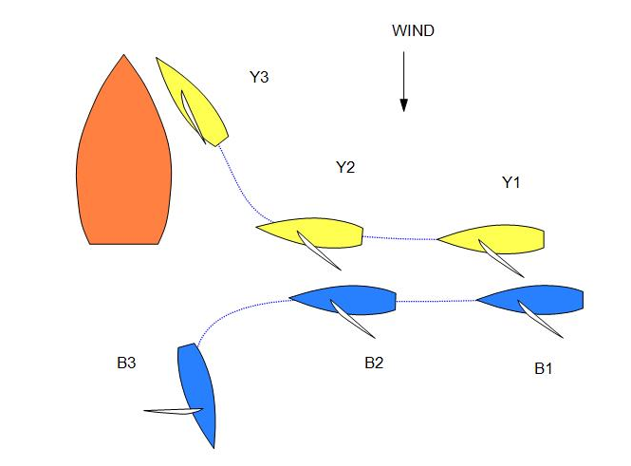
Before the start, and before approaching any starting mark to start, Yellow and Blue approach a large moored boat with Yellow half a length ahead. It appears that Blue intends to pass across the stern of the large boat, and that Yellow requires room to pass on the same side on the inside of Blue. Blue does not bear away to give room, and at the last moment Yellow avoids the large boat by luffing sharply and going to windward of it. Before the bow of Blue reaches the stern of the large boat, she gybes away so that she does not pass its stern. There is a Y-flag. What should the call be?
Answer

Penalize Blue. The large boat was an obstruction. Unless Blue elects to pass to windward of it from sufficiently far away, Yellow may assume that they are both going to bear away and pass below the obstruction. It follows that Blue must give room. By not doing so, she broke rule 19.2(b).

MR CALL B14

Rule 16.1 Changing Course
Rule 19 Room to Pass an Obstruction
Definitions Mark and Obstruction

Question

The situation occurs in the pre-start, with approximately 2 minutes to the starting signal. The committee boat is also a starting mark.
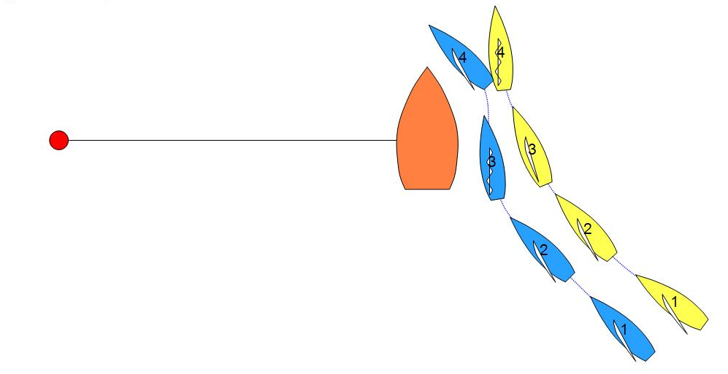
Between situations 3 and 4 Blue makes a big and rapid change of course, backing her jib to bear away, and does not give Yellow room to keep clear. There is contact between Blue and Yellow. Both boats Y-flag. What should the call be?

Answer
Penalize Blue. Rule 19, together with the relevant rules of Section A and B applies when the boats are passing the committee boat in the pre-start, so when Blue changes course she must comply with rule 16.1. Blue is a right-of-way boat changing course. She did not give Yellow room to keep clear and broke rule 16.1.

MR CALL B15

Rule 11 On the Same Tack, Overlapped
Rule 16.1 Changing Course
Rule 19 Room to Pass an Obstruction

Question 1
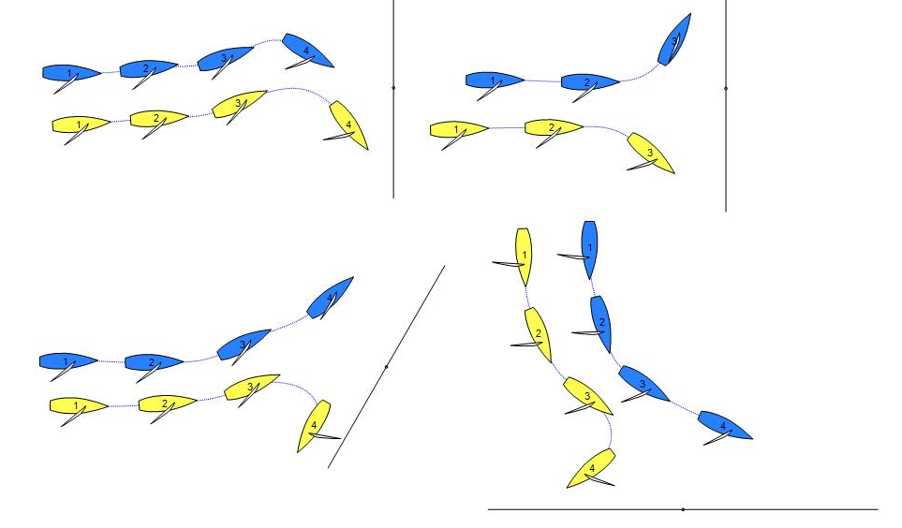
Blue and Yellow are overlapped on port tack, with Yellow as the leeward, right-of-way boat. They approach a continuing obstruction on courses that make it clear that Yellow is the inside boat, or at an angle of approximately 90 degrees to the shoreline so that it is unclear which boat will be the inside boat when they reach the obstruction. Yellow begins to luff or maintains her course and Blue keeps clear. When Yellow is approximately one and a half lengths from the obstruction she suddenly bears away and passes the obstruction to port leaving Blue clear astern. There is a Y-flag. What should the call be?
Answer 1
Display the green and white flag. Rule 11 applies, and rule 19 also applies when it becomes clear that the boats are at the obstruction. Yellow has right of way and can choose to luff or bear away as she pleases provided she complies with rule 16.1. If Yellow and Blue bear away to pass the obstruction to port, Yellow must give room to Blue while the boats are overlapped. If Blue becomes clear astern, she must comply with rule 19.2(c). In the situations shown, no rules are broken.

Question 2
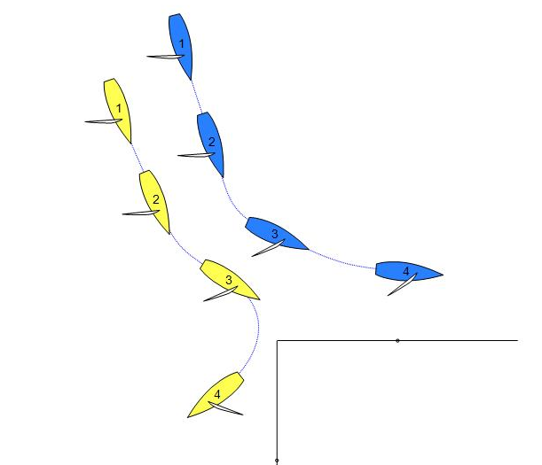
In the pre-start, Blue and Yellow overlapped on port tack approach the outer end of a dock. Before the boats are at the obstruction, Yellow, to leeward, luffs slightly and Blue keeps clear. Yellow suddenly bears away, leaving the obstruction to port. Blue leaves the obstruction to starboard. There is a Y-flag. What should the call be?

Answer 2
Yellow has right of way and may choose to luff or bear away as she pleases provided she complies with rule 16.1. Display the green and white flag.

MR CALL B16

Rule 10 On Opposite Tacks
Rule 19 Room to Pass an Obstruction
Rule 21 Exoneration
Definitions Overlap

Question 1
Yellow and Blue are both sailing more than ninety degrees from the true wind. Blue, on port tack is sailing along a continuing obstruction. Yellow, on starboard tack is approaching the obstruction on a collision course with Blue. Yellow bears away and avoids Blue.
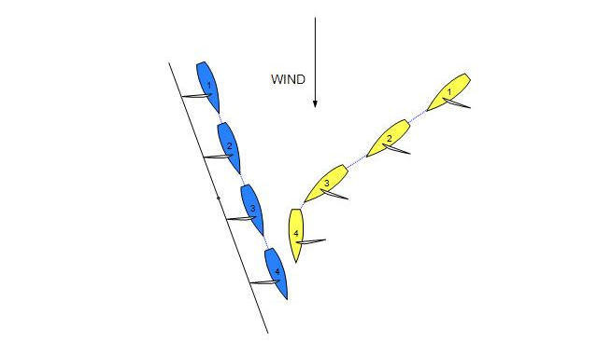
There is a Y-flag. What should the call be?

Answer 1
Display the green and white flag. Both boats are sailing more than ninety degrees from the true wind and are overlapped. Yellow is the outside boat and is required by rule 19.2(b) to give Blue room between her and the obstruction. By bearing away to give room between positions 3 and 4 Yellow fulfilled her obligation under rule 19.2(b).

At position 3 Yellow needed to take avoiding action; therefore Blue was not keeping clear under rule 10. However Blue was sailing within the room to which she was entitled under rule 19.2(b) and is therefore exonerated under rule 21(a).

Question 2
Blue is sailing a course that is more than ninety degrees from the true wind on port tack along a continuing obstruction. Yellow is sailing an upwind course on starboard tack and is approaching the obstruction on a collision course with Blue. When it is obvious that Blue is not going to change course, Yellow luffs and avoids Blue.

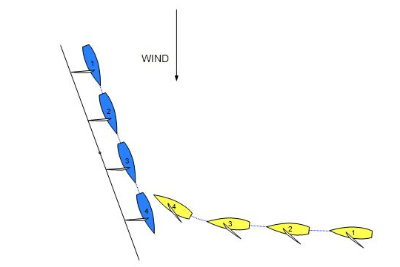
There is a Y-flag. What should the call be?

Answer 2
Penalize Blue.

The definition Overlap only applies between boats on opposite tacks when both are sailing more than ninety degrees from the true wind. Since Yellow is not sailing at more than ninety degrees from the wind, the boats are not overlapped and rule 19.2(b) does not apply. Yellow does not have to give room to Blue. When Yellow has to luff, Blue does not keep clear and breaks rule 10.

MR CALL B17

Definitions Keep Clear

Question


When Blue, a keep-clear boat, passes her bow over Yellow's transom, is Blue keeping clear?

Answer

Yes.
MR CALL B18

Rule 11 On the Same Tack, Overlapped
Rule 12 On the Same Tack, Not Overlapped
Rule 15 Acquiring Right of Way

Question

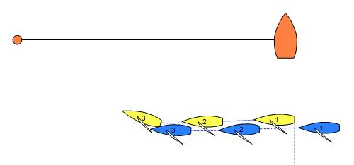
Yellow and Blue are beam reaching on starboard tack in the pre-start with Yellow clear ahead and slightly to windward of Blue’s course line. Yellow releases her sail, and Blue creates an overlap to leeward, without either boat changing course. The separation between the boats is only a few centimetres. Yellow luffs to keep clear and there is immediate contact. Both boats Y-flag. What should the call be?
Answer

Penalize Blue. Blue obtains right of way as a result of Yellow reducing speed. While the change in speed is a consequence of an action by Yellow, an increase or decrease in speed is not in itself an 'action' within the meaning of the second part of rule 15.

Therefore, rule 15 applies when Blue acquires right of way. As Blue creates the overlap so close that Yellow has no possibility of keeping clear, Blue does not give Yellow room to keep clear and breaks rule 15.

MR Call B19
Rule 10 On Opposite Tacks
Rule 19.2 Giving Room at an Obstruction
Definition Keep Clear, Overlap

Question 1

Prior to the start, Yellow, on starboard, and Blue, on port, are sailing more than ninety degrees from the true wind. Both boats are sailing towards an obstruction.
At position 3, Yellow luffs to avoid Blue and displays a Y flag.

What should the call be?

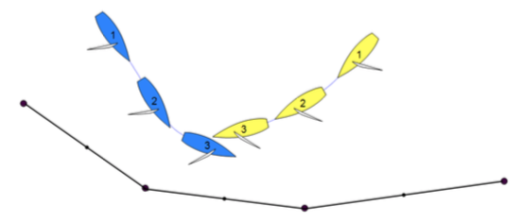
Answer 1

Penalize Blue.

Yellow is the right of way boat and the umpires are certain that Yellow has chosen to pass the obstruction on her port side (rule 19.2(a)).

For the purpose of rule 19, the determination of inside and outside boat is relative to the right of way boat and the obstruction when the boats are at the obstruction. As Yellow is passing the obstruction on her port side, any boat that is on the port side of Yellow is an inside boat and any boat on the starboard side of Yellow is an outside boat.

At position 2 Blue is the keep clear boat that also has to give Yellow room at the obstruction. Yellow changes course from positions 1 to 2 and Blue has room to keep clear. After position 2, Blue fails to keep clear and give Yellow room to pass the obstruction.
Question 2

Would the answer be different if Blue was sailing parallel and close to the obstruction?

Answer 2

No.

Question 3

Prior to the start, Yellow, on starboard, and Blue, on port, are sailing more than ninety degrees from the true wind and both boats are sailing towards an obstruction. Yellow is on a course that the umpires cannot be certain as to the side Yellow will pass the obstruction. Blue changes course to starboard and Y flags.

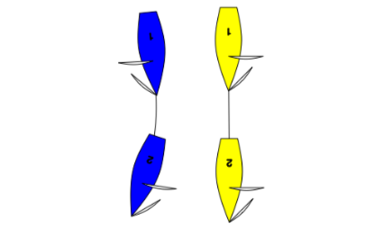

Answer 3

Display the green and white flag.

Rule 19.2(b) applies when two boats are at an obstruction. In order to determine the inside and outside boat, the umpires need to be certain whether the right-of-way boat has chosen to pass the obstruction on her port side or on her starboard side.

At position 2, the right-of-way boat is sailing perpendicular to the obstruction. Therefore, it is not possible to clearly identify which boat is the “inside” boat. When the umpires are not certain which boat is the “inside boat,” no part of rule 19 creates any obligations, and rule 11 requires Blue to keep clear.
MR CALL C1

Rule 8 Last Point of Certainty (C2.5)
Rule 11 On the Same Tack, Overlapped
Section C At Marks and Obstructions: Preamble
Rule 19.2(b) Giving Room at an Obstruction

Question 1

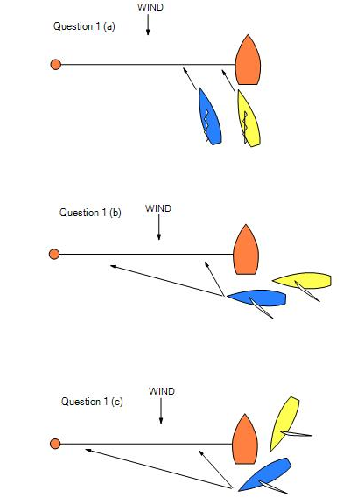
Blue and Yellow are approaching the committee boat end of the starting line. How do the umpires decide if they are approaching a starting mark to start?
Answer 1

In each of Diagrams a, b, and c the boats may be approaching a starting mark to start. The umpires will use the speed and course of the boats in the prevailing conditions and the time remaining before the starting signal to decide if they are approaching a starting mark to start. Since match race starting lines are short, the boats may even be approaching the far end (Diagram b). However, until both umpires agree that the boats are approaching to start, they will decide that they are not (see rule 8 Last Point of Certainty).
Question 2

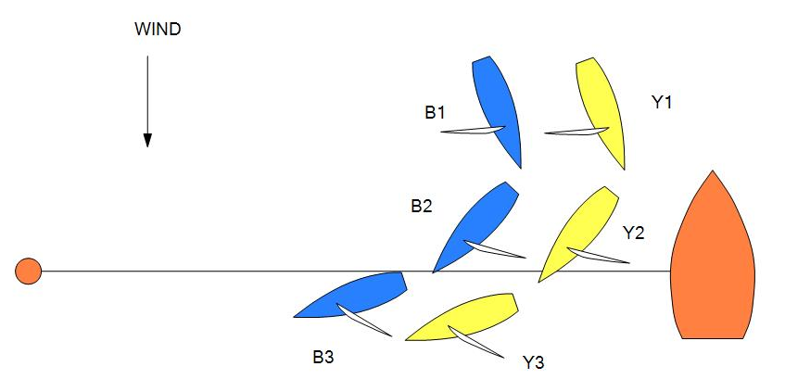
Before starting Blue and Yellow are on the course side of the starting line sailing a course that is more than ninety degrees from the true wind on port tack. Blue gives room for Yellow to pass the committee boat. There is a Y-flag. What should the call be?

Answer 2

Display the green and white flag.

A boat cannot be approaching a mark to start until approaching to pass the mark on the required side. At position 1, Yellow was entitled to room under rule 19.2(b), which was given. This also applies when both boats have been recalled.

MR CALL C2

Rule C7.2 Penalty System: All Penalties
Rule C7.3 Penalty System: Penalty Limitations

Question

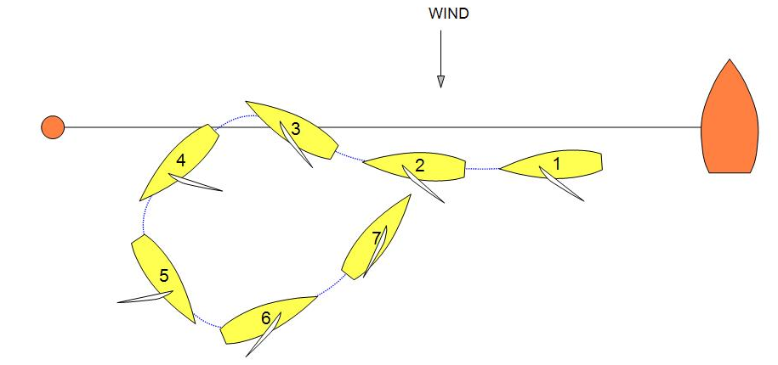
A boat that has been penalized during the pre-start is reaching down the line just before starting. At the starting signal she luffs just enough to cross the starting line and before becoming close-hauled, she bears away, gybes, and sails off on a close-hauled course on the other tack. Has she taken the penalty as required by rule C7?

Answer

Yes. The boat was required to start before taking her penalty, but she did not have to begin taking it from a close-hauled course.
MR CALL D1

Rule 11 On the Same tack
Rule 16.1 Changing Course
Definitions Keep Clear and Room

Question 1

Shortly after the start Yellow and Blue are close-hauled on port tack. The boats are overlapped and Yellow is keeping clear to windward. As the boats pass to leeward of mark L, an inflatable buoy that is not a mark on this leg, Blue luffs and Yellow responds. Yellow stops luffing when she hits the mark amidships, which causes Blue to curtail her luff. Both boats display flag Y. What should the call be?

Answer 1

Penalize Blue. When Blue, the right of way boat, changes course she has to give room according to rule 16.1. It is not seamanlike to hit a mark.

Because mark L is not a mark on this leg, rules 18 and 31 do not apply.

Question 2

Would the answer be the same if the boats were passing to leeward of an object that was not big enough to rank as an obstruction, but nevertheless limited her ability to respond and/or could cause damage to the hull or foils?

Answer 2

Yes. Provided Yellow was initially keeping clear, Blue must give her room to respond in a seamanlike way when she changes course.

MR CALL D2

Rule 10 On Opposite Tacks
Rule 16.1 Changing Course

Question

Blue and Yellow approach one another on a windward leg. As Yellow bears away to pass Blue's stern, Blue luffs. Yellow attempts to bear away more but there is contact between the port quarter of Blue and the bow of Yellow. There is a Y-flag. What should the call be?
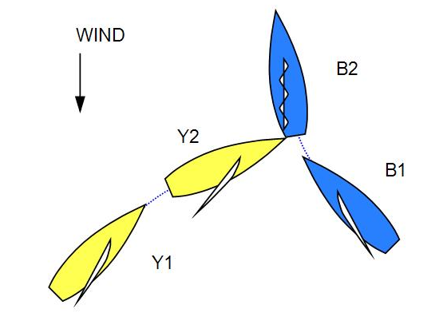
Answer

Provided the umpires are satisfied that Yellow was keeping clear before Blue luffed, Blue broke rule 16.1 by changing course without giving Yellow room. Penalize Blue.

MR CALL D3

Rule 20 Room to Tack at an Obstruction

Question

Approaching an obstruction, Yellow and Blue are sailing upwind on the same tack. Blue hails and signals Yellow for room to tack. Yellow believes that Blue is sailing below a close-hauled course and she ignores the hail. Both boats protest. What should the call be?

Answer

Penalize Yellow. When the hailing boat is sailing upwind, the hailed boat must always respond to the hail in accordance with rule 20.2(b).

In addition, if Blue hailed for room to tack when it was clear that she was sailing below a close-hauled course, then Blue broke rule 20.1(b). Penalize Blue.

MR CALL D4

Rule 10 On Opposite Tacks
Rule 11 On the Same Tack, Overlapped
Rule 12 On the Same Tack, not Overlapped
Rule 15 Acquiring Right of Way
Rule 21 Exoneration

Question 1

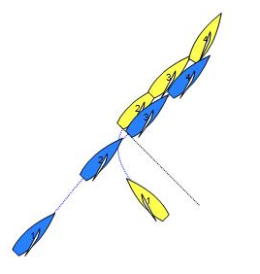
Yellow and Blue are on a beat to windward with Yellow on starboard tack and Blue on port tack. Yellow passes head to wind and completes a tack clear ahead and slightly to windward of Blue’s course line. Her tack slows Yellow down, and Blue creates an overlap to leeward, without either boat changing course. The separation between the boats is only a few centimetres. Yellow luffs to keep clear and there is immediately contact. Both boats Y-flag. What should the call be?
Answer 1

Blue has no need to alter course before Yellow completes her tack. After Yellow completes her tack Blue has room to keep clear by bearing away if needed, so Yellow fulfils her obligation under rule 15 to initially give Blue room to keep clear. When Blue shortly thereafter acquires right of way by establishing a leeward overlap, Blue must give Yellow room to keep clear under rule 15.

If, when the overlap is established, Yellow makes every effort to keep clear but is unable to do so, then Blue breaks rule 15. Yellow breaks rule 11 but will be exonerated under rule 21(a). Penalize Blue.

However, if Yellow does not make every effort to keep clear and Blue, after initially giving room, is then required to take avoiding action or there is contact, then Yellow breaks rule 11. Penalize Yellow.

Question 2

Would the answer be different if Yellow completed the tack clear ahead and further to windward, but was moving forward at slower speed than Blue and slipping sideways reducing the separation between Blue and Yellow.

Answer 2

No.
MR CALL D5

Rule 10 On Opposite Tacks
Rule 16.1 Changing Course

Question 1

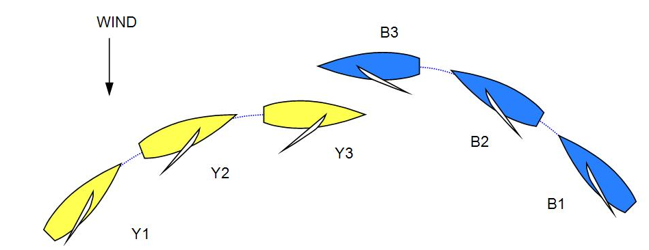
On a windward leg, Blue and Yellow approach one another. At approximately four hull lengths from Blue, Yellow bears away to avoid Blue. Blue then bears away, so that the boats remain on a collision course. Yellow and Blue continue to bear away in the same way, until they finally pass one another with the wind approximately abeam. At no time does Blue sail a course that is more than ninety degrees from the true wind. There is a Y-flag. What should the call be?

Answer 1

Display the green and white flag. The relevant rule is 16.1, but Blue has not broken it, because throughout the incident she has given Yellow room to keep clear.

Question 2

In similar circumstances, Yellow's course would allow her to cross ahead of Blue, but Blue luffs to a collision course and Yellow tacks away in a seamanlike way. There is a Y-flag. What should the call be?

Answer 2

Display the green and white flag. As in Question 1, the relevant rule is 16.1, and although Blue has forced Yellow to change course, she has not done so without giving her room to keep clear.
MR CALL D6

Rule 16.1 Changing Course
Definitions Room

Question

Blue is close-hauled on port tack and Yellow is close-hauled on starboard tack on a leg to the windward mark. Yellow bears away to a course that is more than ninety degrees from the true wind, and that is below her proper course and as a result Blue has to immediately change course to keep clear. There is a Y-flag. What should the call be?

Answer

Penalize Yellow. Yellow breaks rule 16.1 by not giving Blue room, namely the space to manoeuvre in a seamanlike way.

[Note: Amended Nov 2018]
MR CALL E1

Rule 10 On Opposite Tacks
Rule 11 On the Same Tack, Overlapped
Rule 13 While Tacking or Gybing (C2.6)
Rule 16.1 Changing Course
Rule 18.2 Giving Mark-Room (C2.9)
Rule 21 Exoneration
Definitions Mark-Room (C2.2) and Proper Course (C2.3)

Question

Yellow and Blue are approaching the windward mark on port tack. Yellow enters the zone clear ahead of Blue. Yellow then luffs above her proper course before rounding the mark. Blue bears away to a course between Yellow and the mark. Yellow gybes onto starboard. When next to the mark and while sailing her proper course, Yellow is forced to bear away to avoid Blue.
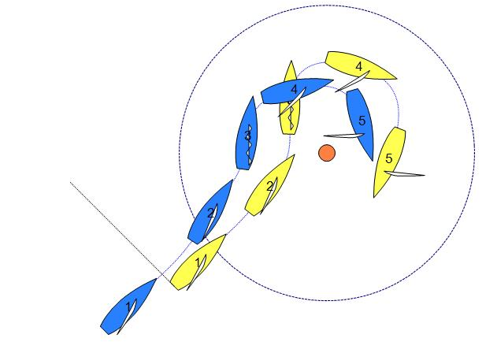
There is a Y-flag. What should the call be?
Answer

Penalize Blue.

When Yellow enters the zone clear ahead, rule 18.2(a)(2) applies and requires Blue to thereafter give Yellow mark-room. Mark-room is room for Yellow to sail her proper course to round or pass the mark. When Yellow luffs after position 2, she is not sailing within the mark-room to which she is entitled, and therefore rule 16.1 requires her to give Blue room to keep clear. Yellow gives room and Blue keeps clear. From position 3 to position 5, Yellow is sailing her proper course, which includes gybing at position 5. Throughout this time Blue is required under rule 18.2(a)(2) to give Yellow room to sail her proper course, which she fails to do.

Blue has neither given Yellow mark-room, nor allowed her to sail her proper course. Penalize Blue and exonerate Yellow.

[Note: Amended Nov 2018]

MR CALL E2

Rule 18.1 When Rule 18 Applies (C2.9)
Rule 18.2(a)(2) Giving Mark-Room (C2.9)

Question

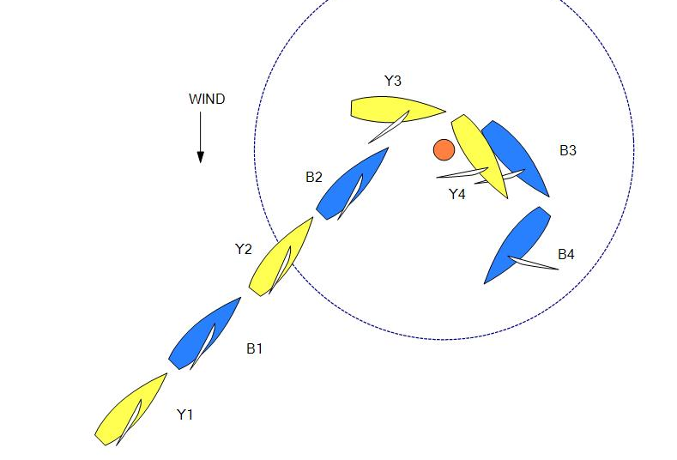
Blue and Yellow approach the windward mark on port tack with Blue clear ahead at the zone. The mark is to be rounded to starboard. After passing the mark, Blue immediately gybes onto starboard tack. How far beyond the mark may Blue sail before gybing and still be entitled to mark-room?

Answer

Blue is entitled to room to sail her proper course to round or pass the mark on the required side [rule 18.2(a)(2)].

At position 3, Blue is on the next leg of the course and the mark is clear astern of her. Therefore, Yellow has given Blue mark-room as required and rule 21 no longer applies. If Blue gybes after this point, she will be subject to rule 13.2 and then rules 15 and 16.1.
MR CALL E3

Rule 15 Acquiring Right of Way
Rule 18.2 Giving Mark-Room (C2.9)
Definitions Mark-Room (C2.2)

Question 1

Yellow enters the zone clear ahead of Blue. Both boats tack and continue to round the mark. Blue becomes overlapped inside Yellow. Both boats Y-flag.

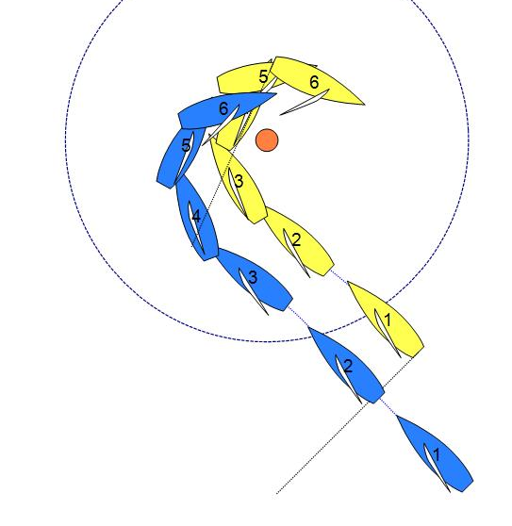
What should the call be?

Answer 1

When Yellow enters the zone, rule 18.2(a)(2) applies until Yellow has rounded the mark.

At position 6, Yellow has not yet completed rounding the mark. If Yellow cannot sail her proper course around the mark without needing to avoid Blue, Blue breaks rule 18.2(a)(2). Penalize Blue. If Yellow at the same time breaks a rule, she is exonerated under rule 21(a).

If Yellow is able to sail her proper course around the mark with no interference, display the green and white flag.
Question 2

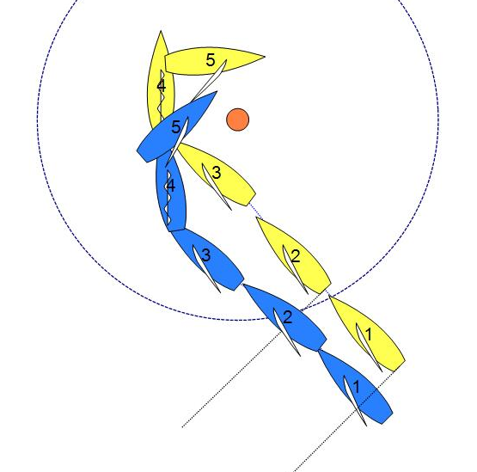
Yellow and Blue enter the zone overlapped. Both boats tack and continue to round the mark. Blue becomes overlapped inside Yellow. Yellow’s boom touches Blue’s hull. Both boats Y-flag. What should the call be?

Answer 2

Penalize Blue. See Answer 1.

MR CALL E4

Rule 11 On the Same Tack, Overlapped
Rule 16.1 Changing Course
Rule 18.2 Giving Mark-Room (C2.9)
Definitions Mark-Room (C2.2) and Room

Question

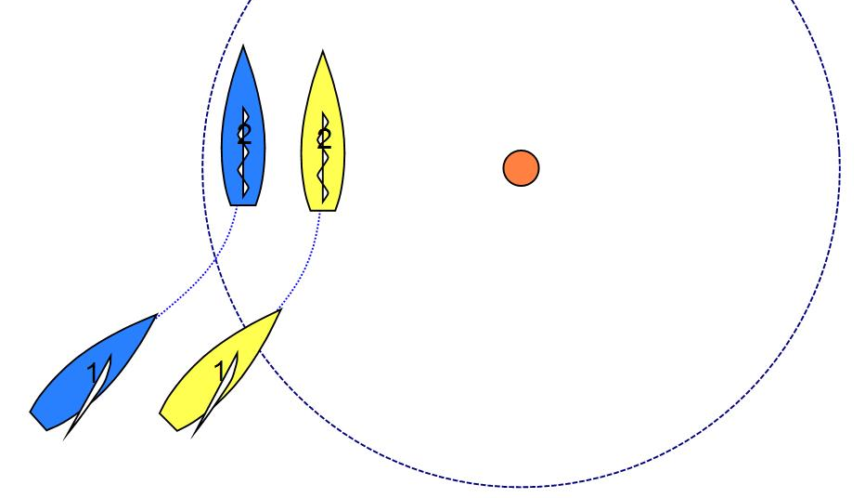
Blue and Yellow approach the windward mark overlapped on port tack with Yellow to leeward and on the layline at the zone. Before Yellow rounds the mark she luffs head to wind. Blue responds to the luff and keeps clear. There is a Y-flag. What should the call be?
Answer

Display the green and white flag.

Blue is required by rule 11 to keep clear and by rule 18.2(a)(1) to give mark-room, and she does so. When Yellow luffs, she is not sailing within the mark-room to which she is entitled; therefore rule 16.1 requires her to give Blue room to keep clear. However nothing in the rules prevents Yellow from sailing above her proper course while the boats are rounding or passing the mark.

MR CALL E5

Rule 18.1 When Rule 18 Applies (C2.9)
Rule 18.2 Giving Mark-room (C2.9)
Rule 18.3 Tacking or Gybing (C2.9)

Question 1
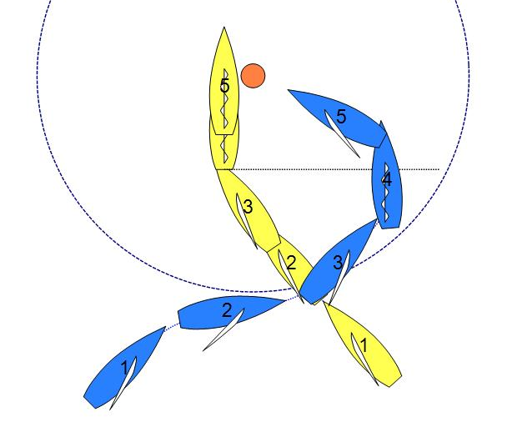
Yellow on starboard tack and Blue on port tack, both close-hauled, are approaching the windward mark to be left to starboard. Blue bears away and passes astern of Yellow. When Yellow reaches the zone, she is overlapped and on the inside of Blue. Yellow luffs slowly and nearly stops head to wind with the mark abeam. While Yellow is luffing, Blue tacks to starboard and bears away towards the mark. Yellow does not give room at the mark, and Blue luffs to avoid a collision. There is a Y-flag from Blue. What should the call be?

Answer 1
Display the green and white flag.

When Yellow reaches the zone, she is inside boat and therefore entitled to mark-room under rule 18.2(a)(1) until she has rounded or passed the mark. Blue keeps clear of Yellow and gives Yellow mark-room.

Question 2
Would the answer be different if Blue completes her tack outside the zone?

Answer 2
No.
MR CALL E6

Rule 11 On the Same Tack, Overlapped
Rule 13.1 While Tacking or Gybing (C2.6)
Rule 18.2 Giving Mark-Room (C2.9)
Rule 21 Exoneration
Definitions Mark-Room (C2.2)

Question
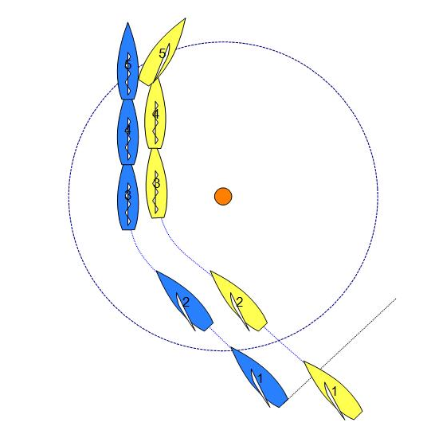
Blue and Yellow on starboard tack approach the windward mark, to be left to starboard, with Yellow overlapped on the inside of Blue at the zone. After passing the port-tack layline both boats luff head to wind. At position 3 Blue has given Yellow enough room to tack. Both boats continue forward with the gauge between the boats reducing until, before leaving the zone, Yellow passes head to wind. There is contact as Yellow’s stern swings. Both boats Y-flag. What should the call be?

Answer
Penalize Blue. When Yellow enters the zone overlapped on the inside of Blue, rule 18.2(a)(1) applies and requires Blue to thereafter give Yellow mark-room, which is room for Yellow to sail her proper course to round or pass the mark. When Yellow continues straight after position 3, she is not sailing within the mark-room to which she is entitled. Rule 11 requires her to keep clear of Blue and she does so.

At position 5, while still in the zone, Yellow tacks which is her proper course, and Blue fails to give her room to do so. Blue breaks rule 18.2(a)(1). Because Yellow is sailing within the mark-room to which she is entitled, she is exonerated under rule 21(a).

Note that rule 18.3(b) does not apply in positions 3 and 4, because Yellow is not the right-of-way boat.
MR Call E7

Rule 11 On the Same Tack, Overlapped
Rule 18.3(b) Tacking or Gybing (C2.9)
Rule 21 Exoneration
Definitions Mark-Room (C2.2) and Proper Course (C2.3)

Question 1

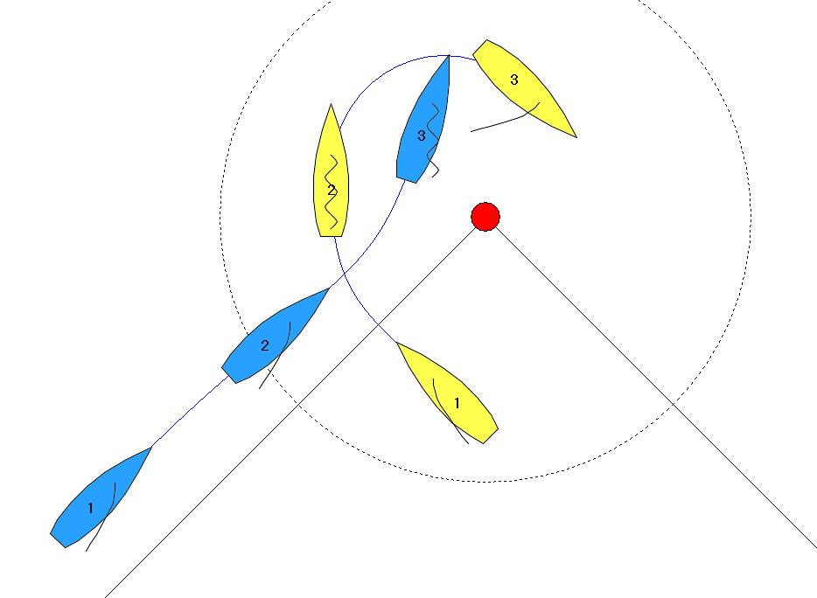
Yellow and Blue approach the windward mark on opposite tacks with Yellow on starboard. Yellow keeps on sailing on starboard beyond her proper course to round the mark before she passes head to wind. Yellow then bears away on her proper course to round the mark and Blue has to luff to give mark-room to Yellow. There is a Y-flag. What should the call be?
Answer 1

Display the green and white flag.

Yellow broke rule 18.3(b) when she sailed farther from the mark than needed to sail her proper course, however she did not affect Blue's course during the time rule 18.3(b) applied. Once Yellow passed head to wind rule 18.3(b) no longer applied. Therefore, she is not penalized for that breach.

After Yellow passed head to wind at position 2, rule 18.3(b) no longer applied. By luffing up behind Yellow, Blue gave Yellow mark-room. No rules are broken.

Question 2

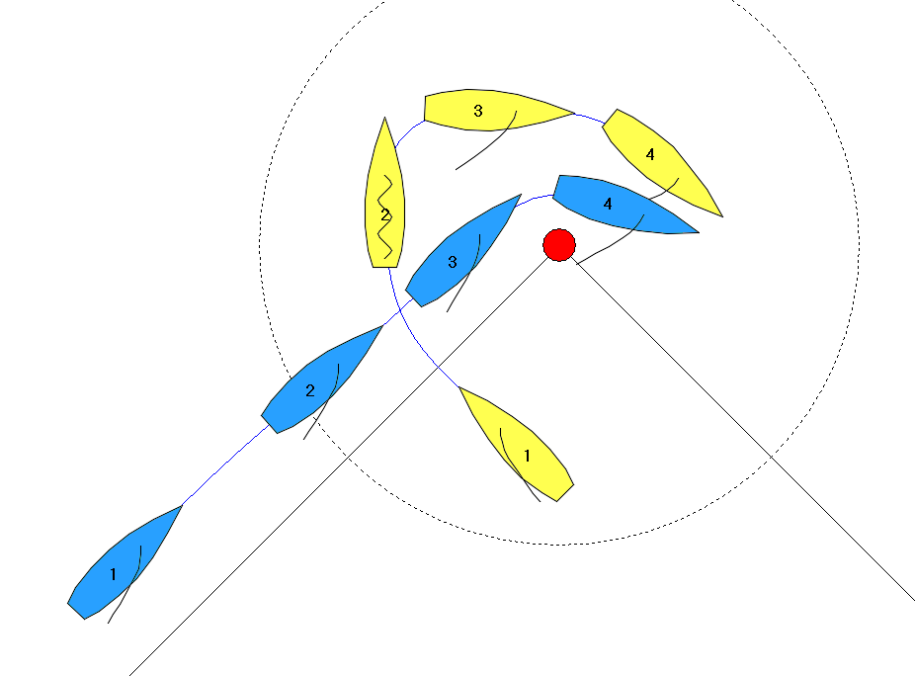
The situation starts as in Question 1, but after Yellow passes head to wind, Blue sails in between Yellow and the mark. When Yellow bears away to round the mark on her proper course there is contact between the boats. There is a Y-flag. What should the call be?
Answer 2

Penalize Blue.

Yellow was entitled to mark-room under rule 18.2(a)(1) and, from the moment she began luffing to round the mark, she was sailing her proper course to round the mark. Therefore, she is exonerated under rule 21(a) for her breach of rule 11. Blue failed to give Yellow mark-room as required by rule 18.2(a)(1).

Yellow broke rule 18.3(b) before she passed head to wind, but is not penalized for that breach (see Answer 1).

[Note: Amended Nov 2017]

MR Call E8

Rule 10 On Opposite Tacks
Rule 13 While Tacking or Gybing (C2.6)
Rule 18.2 Giving Mark-Room (C2.9)
Rule 18.3(b) Tacking or Gybing (C2.9)
Rule C6.5(b) Controlling position
Rule C8.3 Penalties Initiated by Umpires
Definitions Keep Clear, Mark-Room (C2.2), Proper Course (C2.3)

Question 1

Blue on port tack and Yellow on starboard tack are approaching the windward mark on a collision course. The umpires agree that Yellow sails beyond the point where her proper course would be to tack to round the mark. Blue tacks to starboard and keeps clear of Yellow. There is a Y-flag at position 4.

What should the call be?
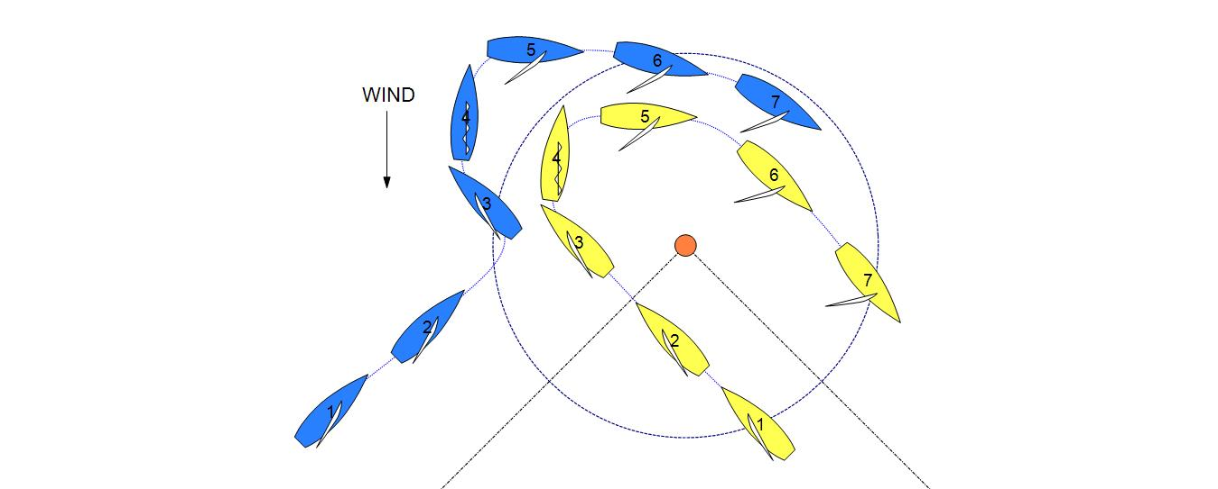
Answer 1

Penalize Yellow with a red flag (or possibly a double).

When Yellow first enters the zone overlapped inside Blue, she is entitled to mark-room under rule 18.2(a)(1). However, as an inside overlapped right-of-way boat, Yellow breaks rule 18.3(b) by sailing farther from the mark than needed to sail her proper course before she tacks, and in doing so she affects Blue’s course. Display the yellow flag.

A boat is in a “controlling position” when she is ahead and able to manoeuver towards the next mark without impediment, or she is in a position to be able to impede, affect or change the actions of the other boat without breaking a rule. Because Yellow could not force Blue to tack without breaking rule 18.3(b), she was not in a “controlling position” in this situation. By breaking rule 18.3(b) and forcing Blue to tack Yellow gained a controlling position.

If the umpires were satisfied that Yellow has broken rule 18.3(b) deliberately or has gained an advantage by breaking the rule after allowing for a penalty, they would give Yellow a second penalty under rule C8.3. See also MR Call M2.

If the umpires were not satisfied that either of these conditions existed, the umpires would give Yellow a red-flag penalty under rule C6.5(b).

Question 2

Blue on port tack and Yellow on starboard tack are approaching the windward mark on a collision course. The umpires agree that Yellow sails beyond the point where her proper course would be to tack to round the mark. Blue tacks to starboard to avoid Yellow, but before she reaches a close-hauled course Yellow has to luff to avoid Blue. Both boats display a Y-flag at position 4.

What should the call be?

Answer 2

Penalize Yellow with a red flag (or possibly a double) and Blue.

Blue breaks rule 13.1 by not keeping clear while tacking. Because Blue is neither compelled to break a rule, nor entitled to room or mark-room, she cannot be exonerated for her breach.

Yellow, the inside overlapped right-of-way boat, breaks rule 18.3(b) by sailing farther from the mark than needed to sail her proper course before she tacks, and affects Blue’s course while doing so.

Coming into the situation, neither boat was in a controlling position because neither boat could impede, affect or change the other boat’s course while complying with the applicable rules. See Answer 1. By breaking rule 18.3(b), Yellow gained a controlling position on Blue.

If the umpires were satisfied that Yellow broke rule 18.3(b) deliberately or gained an advantage by breaking the rule after allowing for a penalty, they would give Yellow a second penalty under rule C8.3. This should be a red-flag penalty under rule C5.3 (red and second yellow flag) so that Yellow is behind Blue in the race. See also MR Call M2.

If the umpires were not satisfied that either of these conditions existed, the umpires would give Yellow a red-flag penalty under rule C6.5(b) (yellow and then red flag). This would put Yellow behind Blue and Blue would still have a penalty.

Question 3

Blue on port tack and Yellow on starboard tack are approaching the windward mark on a collision course. The umpires agree that Yellow sails beyond the point where her proper course would be to tack to round the mark. Blue holds her course. Yellow has to tack to avoid Blue. Both boats display Y flags at position 4.

What should the call be?

Answer 3

Penalize Blue with a red flag (or possibly a double) and Yellow (with possibly a double).

Yellow, the inside overlapped right-of-way boat, breaks rule 18.3(b) by sailing farther from the mark than needed to sail her proper course before she tacks, and affects Blue’s course while doing so (Blue is unable to bear away to round the mark).

Blue breaks rule 10 by not keeping clear. Because Blue is neither compelled to break a rule, nor entitled to room or mark-room, she cannot be exonerated for her breach.

Coming into the situation, neither boat was in a controlling position because neither boat could impede, affect or change the other boat’s course while complying with the applicable rules. See Answer 1.

If the umpires were satisfied that Yellow broke rule 18.3(b) deliberately, they would give Yellow a second penalty under rule C8.3. See also MR Call M2.

By breaking rule 10, Blue has gained a controlling position. If the umpires were satisfied that Blue has broken rule 10 deliberately or has gained an advantage by breaking the rule after allowing for a penalty, they would give Blue a second penalty under rule C8.3. See also MR CALL M2.

If the umpires give both Yellow and Blue a double penalty, then Blue‘s second penalty should be a red-flag penalty under rule C5.3 (red and second blue flag) as Blue gained a controlling position. This would put Blue behind Yellow and Yellow would still have a penalty.

If the umpires were not satisfied that either of these conditions existed, the umpires would give Blue a red-flag penalty under rule C6.5(b).

MR CALL E9

Rule 18.1 When Rule 18 Applies (C2.9)
Rule 18.2 Giving Mark-Room (C2.9)

Question

Yellow enters the zone of a windward mark clear ahead of Blue, passes the mark and sails completely out of the zone. Yellow then completes a penalty just before position 3 and is on starboard tack on a course that is more than ninety degrees from the true wind. Blue on port tack is bearing away to round the windward mark.

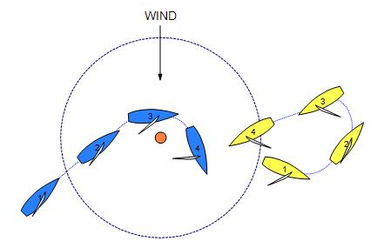
Does rule 18 apply between Yellow and Blue?

Answer

Yes. When Yellow first enters the zone clear ahead of Blue, she is entitled to mark-room under rule 18.2(a)(2). Yellow’s entitlement to mark-room ceases at position 1 when she leaves the zone, under rule 18.2(c). At this point the boats are not overlapped.

As Blue remains in the zone she is considered the first boat to reach the zone when rule 18.2(a) is re-applied. Blue is therefore entitled to mark-room under rule 18.2(a)(2).

MR CALL E10

Rule 18.1 When Rule 18 Applies (C2.9)
Rule 18.2 Giving Mark-Room (C2.9)

Question
Blue and Yellow approach the windward mark on port tack with Blue overlapped to windward at the zone. The mark is to be rounded to starboard.
Instead of rounding the mark, both boats slow down and continue sailing to windward. At position 3 Yellow leaves the zone while clear ahead of Blue. Blue remains inside the zone.
As the boats bear away they become overlapped again, this time with Yellow overlapped outside Blue.
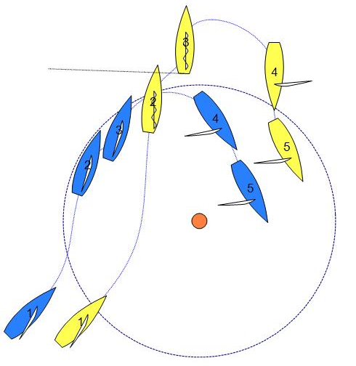
At position 5 there is a Y-flag from Yellow. What should the call be?
Answer
Display the green and white flag.

When Yellow first enters the zone overlapped inside Blue, she is entitled to mark-room under rule 18.2(a)(1). However, Yellow’s entitlement to mark-room ceases at position 3 when she leaves the zone; see rule 18.2(b). At this point the boats are not overlapped.

As Blue remains in the zone she is considered the first boat to reach the zone when rule 18.2(a) is re-applied. Blue is therefore entitled to mark-room under rule 18.2(a)(2). Yellow gives mark-room to Blue.
MR Call E11

Rule 10 On Opposite Tacks
Rule 11 On the Same Tack, Overlapped
Rule 18 Mark-Room (C2.9)
Rule 19 Room to Pass an Obstruction
Definitions Keep Clear, Overlap
Question 1
Yellow and Blue in one match and Green in another match are approaching the windward mark overlapped. The mark is to be rounded to starboard
When Green enters the zone, she is overlapped with Yellow and Blue, who are overlapped on port tack. Yellow and Blue are on a collision course with Green.
Blue does not hail for room to tack. At position 3, Blue bears away and passes close behind Green. Yellow luffs and tacks to avoid Green and Y-flags.
What should the call be?
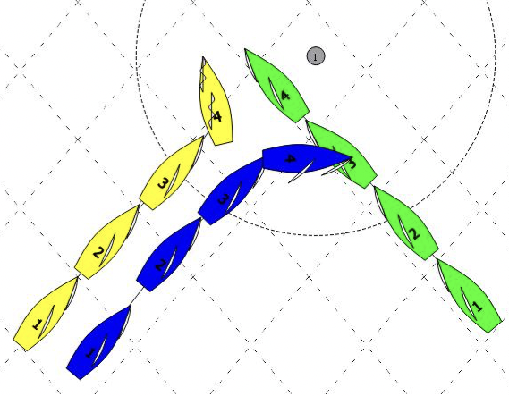

Answer 1
Green is an inside overlapped boat and therefore entitled to mark-room from Blue and Yellow under rule 18.2(a)(1) (rule C2.9). Blue is an inside overlapped boat relative to Yellow and therefore entitled to mark-room from Yellow under rule 18.2(a)(1) (rule C2.9).
If Yellow gave Blue room to tack but Blue did not tack, display the green and white flag. Yellow has given mark-room to both Blue and Green and Blue has given mark-room to Green. Note that rule 19 does not apply (see rule 19.1(b)).
If Yellow did not give Blue room to tack as part of Blue’s proper course, and/or Blue’s obligation to give Green mark-room, penalise Yellow. Blue does not need to hail nor make arm signals for 'room to tack' as the room required to be given by Yellow is mark-room as required by rule 18, not room as required by rule 20.
Question 2
The situation is the same as in Question 1, but instead of luffing and tacking, Yellow bears away with Blue to pass behind Green and there is contact between Yellow and Green. Blue displays a Y-flag. What should the call be?
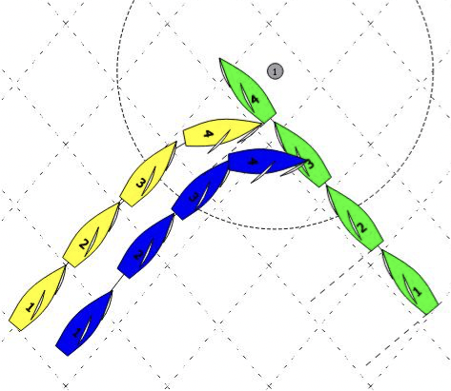
Answer 2
Penalize Yellow.
Rule 19 does not apply, therefore Blue is not required to give Yellow room to pass between Green and herself. Yellow fails to keep clear of (and give mark-room to) both Green and Blue under rules 10, 11, and 18.2(a)(1).
MR CALL G2

Rule 16.1 Changing Course
Definitions Room

Question 1

Blue is sailing to leeward of Yellow. Both boats have spinnakers set. Blue luffs Yellow. What are the obligations on Blue and Yellow?

Answer 1

Yellow is required to keep clear and Blue is required to give Yellow room to respond to her luff. While Yellow is able to keep the majority of her spinnaker filled and drawing she is not entitled to additional room to drop her spinnaker.

If Blue continues her luff so that Yellow, in order to keep clear, has to luff beyond the point where she can keep her spinnaker filled and drawing, then Blue must give Yellow room to drop her spinnaker.

Whether or not Yellow drops her spinnaker at that time, she is still required to keep clear. If she does not drop her spinnaker at that time, then Blue is not required to give her additional room to drop the spinnaker later in that luff.

Question 2
If Yellow does not drop her spinnaker and passes head to wind to keep clear, is Blue giving Yellow room to keep clear in a seamanlike way?

Answer 2

Yes. Blue may continue to luff as long as she has previously given Yellow room to drop her spinnaker.

Question 3
Does either answer change if Blue does not have a spinnaker set, or if Blue has a different type of spinnaker set?

Answer 3

No.

MR CALL G4

Rule 15 Acquiring Right of Way

Question

On a course that is more than ninety degrees from the true wind, Yellow establishes an overlap to windward of Blue with her spinnaker. Yellow bears away, without breaking the overlap, and overlaps Blue to leeward.

Does rule 15 apply?

Answer

Yes. At the moment Yellow becomes right of way as the leeward boat, rule 15 begins to apply.

MR CALL G5

DELETED

[Note: Amended Nov 2018]

MR CALL G7

Rule 11 On the Same Tack, Overlapped
Rule 16.1 Changing Course
Rule C6.5(b) Red-Flag Penalty
Rule C7.2 All Penalties
Rule C7.3(d) Penalty Limitations
Rule C8.3 Penalties Initiated By Umpires

Question 1

Yellow and Blue are sailing a course that is more than ninety degrees from the true wind with Blue overlapped to windward of Yellow. Yellow luffs slowly and Blue responds, but Blue’s response is not enough for her to keep clear. There is contact between Blue’s spinnaker and Yellow’s rigging. Blue is blocking Yellow’s wind and she overtakes Yellow. There is a Y-flag. What should the call be?
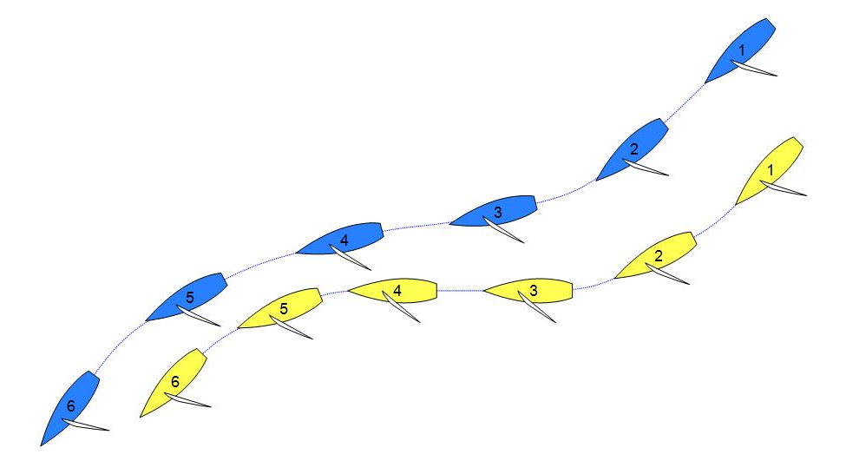

Answer 1

If Blue could have kept clear but either responded too slowly or not enough, then Blue has broken rule 11. Penalize Blue.

If in addition the umpires are satisfied that Blue has broken a rule deliberately or has gained an advantage by breaking the rule after allowing for a penalty, they would give Blue a second penalty under rule C8.3. If the umpires were not satisfied that either of these conditions existed, but are satisfied that Blue gained a controlling position because of the breach, the umpires would give Blue a red-flag penalty under rule C6.5(b). See also MR Call M2.
[Note: Amended Nov 2018]
Question 2

Would the answer be different if the Yellow had an outstanding penalty?

Answer 2

No. However, if Blue was given a red-flag penalty under rule C8.3, this would not offset Yellow’s outstanding penalty [rule C7.2(e)]. Blue would have to take her penalty as soon as reasonably possible and Yellow would still have an outstanding penalty.

Question 3

Would the answer be different if the boats are getting closer to the finishing line and Yellow has an outstanding penalty?

Answer 3

No. However, in this situation it is more likely that the conditions for a double penalty are met.

If a double penalty has been signalled to Blue, the first penalty will offset Yellow’s penalty [rule C.7.2(e)]. Blue will not be recorded as finishing until she completes her second penalty and then finishes [rule C7.2(d)].
MR CALL J1

Rule 18.2 Giving Mark-Room (C2.9)
Rule 18.3 Tacking or Gybing (C2.9)
Definitions Proper Course (C2.3)

Question 1

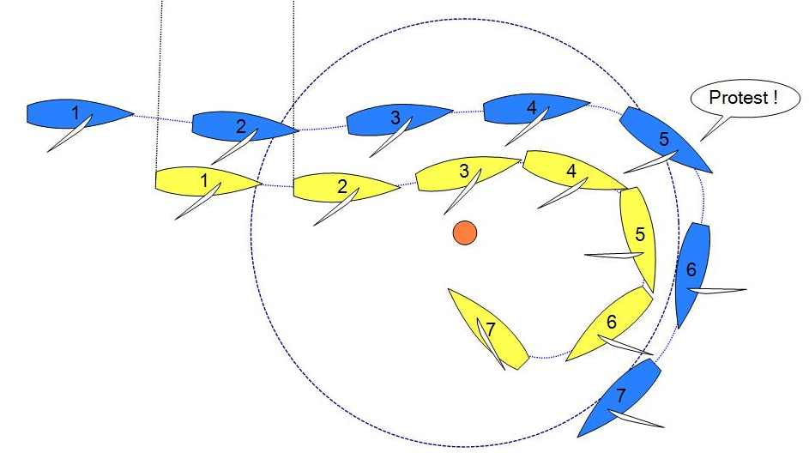
Yellow is approaching the leeward mark below the layline and is clear ahead of Blue at the zone. Very shortly thereafter Blue becomes overlapped outside and to windward of Yellow. At position 5 Blue displays her Y-flag. What should the call be?
Answer 1

Yellow is clear ahead when she enters the zone. Rule 18.2(a)(2) applies and Blue must give her mark-room. When Blue becomes overlapped on the outside, she is required by rule 11 to keep clear of Yellow. Blue gives room and keeps clear.

From the moment the boats overlap until Yellow gybes, rule 18.3 also applies and Yellow shall sail no farther from the mark than her proper course. The umpires must consider factors such as the type of boat, current, wind strength and waves to decide whether Yellow complies with this rule. If the umpires decide that Yellow does not sail farther from the mark than she would in the absence of Blue while rule 18.3 applies, display the green and white flag. If Yellow does sail farther from the mark than her proper course, Yellow breaks rule 18.3. If Yellow affects Blue’s course while she is breaking rule 18.3, penalize Yellow. If not, display the green and white flag.

Question 2

Would the call be different if Yellow was having a problem lowering her spinnaker?

Answer 2

No. Neither the room that has to be given by Blue nor the course that must be sailed by Yellow is changed by unseamanlike boat handling.
MR CALL J2

Rule 18.1 When Rule 18 Applies (C2.9)
Rule 18.3 Tacking or Gybing (C2.9)
Definitions Proper Course (C2.3)

Question

Yellow and Blue enter the zone of the leeward mark overlapped with Blue as the inside right-of-way boat. As Blue’s proper course at the mark includes a gybe, rule 18.3 applies to Blue.
Because of strong current and light wind, Blue’s proper course would take her outside the zone before she gybes and heads back to the mark. When Blue reaches the point where her proper course is to gybe, both boats are outside the zone.
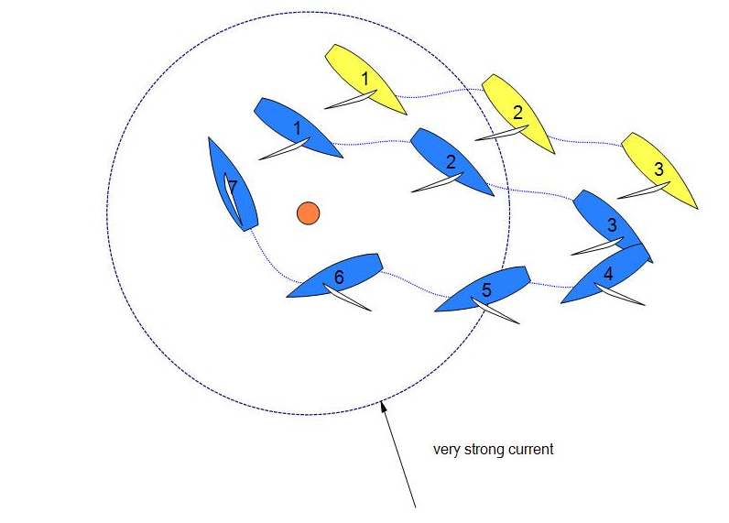
Is Blue still required by rule 18.3 to gybe at that moment? (Position 3)

Answer

No. When both boats have left the zone rule 18, including rule 18.3, no longer applies and therefore Blue is no longer required by rule 18.3 to gybe.
MR CALL K1

Rule 28 Sailing the Course
Definitions Finish (C2.1)

Question 1

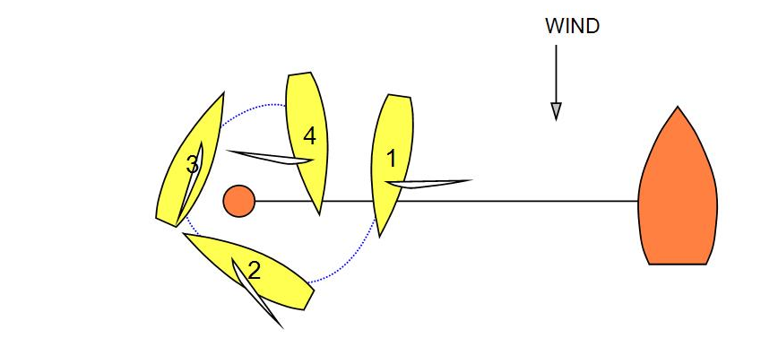
When a boat delays taking her penalty until the finish, is she allowed to take it around the finishing mark?
Answer 1

Yes. Although she sails through the finishing line, she does not finish because she has not yet taken her penalty; see Definition Finish. Her penalty is to tack and, as soon as reasonably possible, bear away to a course that is more than ninety degrees from the true wind in accordance with rule C7.2(a)(2). See also rule C7.2(d).

Question 2

Did she comply with rule 28, Sailing the Course?

Answer 2

Yes. Rule 28 requires that ‘a string representing her track’ would ‘pass each mark on the required side,’ which it did. The rule does not prohibit a boat from rounding a finishing mark (or any other mark) even though as a result her track would pass it on the required side twice.

MR CALL K2

Rule 11 On the Same Tack, Overlapped
Rule 18.2 Giving Mark-Room (C2.9)
Rule 22.2 Taking Penalties

Question
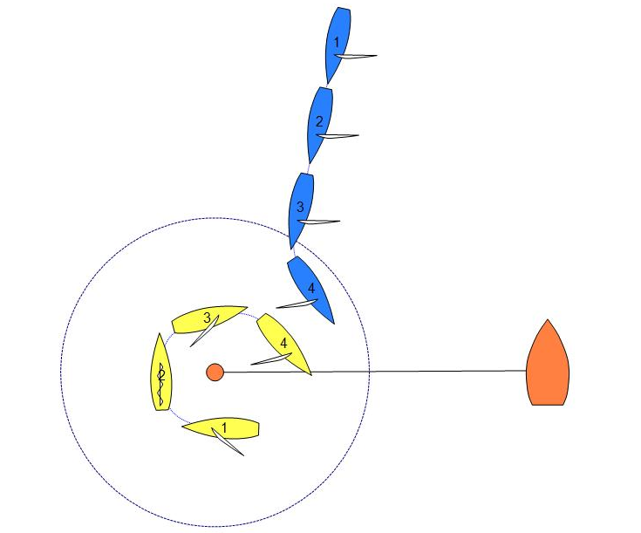
Yellow enters the zone of the finishing mark clear ahead of Blue, and is taking a penalty around the finishing mark. As Yellow tacks and bears away on port, Blue, approaching the mark on starboard, bears away and gybes to port. There is a Y-flag. What should the call be?
Answer
Because Yellow enters the zone clear ahead of Blue, she is entitled to mark- room under rule 18.2(a)(2). When Yellow passes head to wind rule 18.2(a)(2) continues to apply, but as Yellow also begins taking a penalty, she must keep clear of Blue under rule 22.2 until she completes her penalty by bearing away to a course that is more than ninety degrees from the true wind. Although Yellow is sailing within the mark-room to which she is entitled, she is not exonerated for her breach of rule 22.2 under rule 21(a) because rule 21(a) does not include rules in Section D, or rule 64.1(a) because Yellow was not compelled to break rule 22.2.

If Blue is required to take avoiding action before Yellow completes her penalty, Yellow is not keeping clear under rule 22.2, even if Blue is also changing course to give mark-room. Signal that Yellow has completed her penalty and penalize Yellow again for breaking rule 22.2. See MR Call N7.

If Blue’s change of course is not required until after Yellow completes her penalty, display the green and white flag.
MR CALL K3

Rule C5.6 Signals by Umpires
Rule C7.2(a)(2) All Penalties
Rule C7.4(b) Penalty System: Taking and Completing Penalties
Definitions Finish (C2.1)

Question

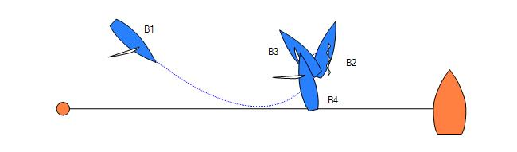
Blue has a penalty outstanding as she approaches the finishing line. She lowers her spinnaker, luffs, passes head to wind, bears way to a close-hauled course on the other tack, reverses her mainsail and sails backwards across the finishing line, now above close-hauled. Has she finished?
Answer

No. Blue cannot finish until she has taken her penalty. She has not borne away to a course that is more than ninety degrees from the true wind as required by rule C7.2(a)(2). The umpires will signal as required in rule C5.6 that the boat is no longer taking a penalty and that the penalty remains.

MR CALL K4

Rule 10 On Opposite Tacks
Rule 11 On the Same Tack, Overlapped
Rule 18.2 Giving Mark-Room (C2.9)
Rule 21 Exoneration
Definitions Mark-Room (C2.2) and Proper Course (C2.3)

Question

Blue has an outstanding penalty. Blue enters the zone of the finishing mark clear ahead of Yellow, and never thereafter leaves the zone. Shortly after position 3 Yellow establishes an inside overlap on Blue. Blue gybes to port and then closes the gap between the boats by heading up and aiming directly at the finishing flag on the race committee boat.

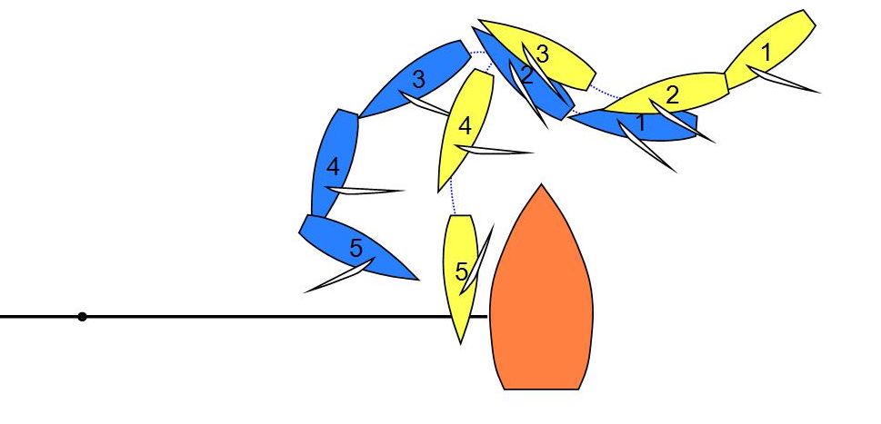
There is contact between Blue and Yellow with no damage. There is a Y-flag. What should the call be?
Answer

Blue was clear ahead when she reached the zone and rule 18.2(a)(2) began to apply. From position 1 and throughout the incident, Yellow is required to give Blue mark-room, which is room for Blue to sail her proper course.

If the umpires decide that Blue is sailing a proper course, penalize Yellow for breaking rule 18.2(a)(2) and exonerate Blue for breaking rule 10 under rule 21(a). If Blue is sailing above her proper course, penalize Blue for breaking rule 10.
MR CALL K5

Rule 18.2(a)(1) Giving Mark-Room (C2.9)
Rule 21 Exoneration
Definitions Mark-Room (C2.2)

Question 1

Blue, with an outstanding penalty, is clear ahead when she reaches the zone of the finishing mark. Blue luffs, tacks and bears away to a course that is more than ninety degrees from the true wind, on port tack at position 4. After position 4, Blue sails at an angle that the umpires agree is her proper course.

After position 4 Yellow (on starboard) bears away to avoid Blue and displays a Y-flag.

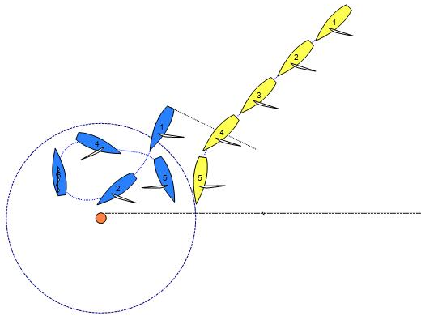
What should the call be?
Answer 1

Display the green and white flag.

Blue is entitled to mark-room. Mark-room for Blue is to sail her proper course to pass the mark [rule 18.2(a)(2)]. While Blue’s course to take her penalty is not a proper course (rule C2.3), once Blue has taken her penalty, she is entitled to sail her proper course from that point until she has finished. Blue breaks rule 10, but is exonerated under rule 21(a).
Question 2

Blue on port and Yellow on starboard are sailing towards the finishing line. When Blue reaches the zone of the finishing mark, she is the inside, overlapped boat.

At position 2, Blue is certain that she has crossed the finishing line and she bears away and gybes to a course to sail close to, but not hitting, the finishing mark. At the same time Yellow bears away to avoid contact with Blue. There is a Y-flag.
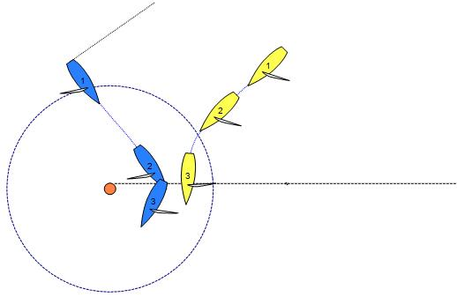
What should the call be?
Answer 2

Display the green and white flag.

Blue is entitled to mark-room. Mark-room for Blue is room to sail her proper course to pass the mark [rule 18.2(a)(1)]. Once Blue has finished she no longer has a proper course, but she has not yet passed the mark. Therefore, the space Blue is entitled to after finishing is simply the space she needs to pass between Yellow and the mark from the time she has finished. By bearing away and gybing from position 2, Blue is not sailing farther from the mark than what she is entitled to.

MR Call K6
Rule 18.2(a)(2) Giving Mark-Room (C2.9)
Rule 21 Exoneration
Rule 22.2 Taking Penalties
Definitions Mark-Room (C2.2) and Proper Course (C2.3)
Rule C7.4 Taking and Completing Penalties
Rule C8.3 Penalties Initiated by Umpires
Question 1
Both boats are approaching the race committee vessel end of the finishing line. Blue has an outstanding penalty. Blue reaches the zone clear ahead of Yellow. Blue tacks onto port tack, gets to a close-hauled course and tacks back onto starboard tack. At position 7, just before Blue reaches a course that is more than ninety degrees from the true wind, there is contact between the boats and both boats protest. What should the call be?
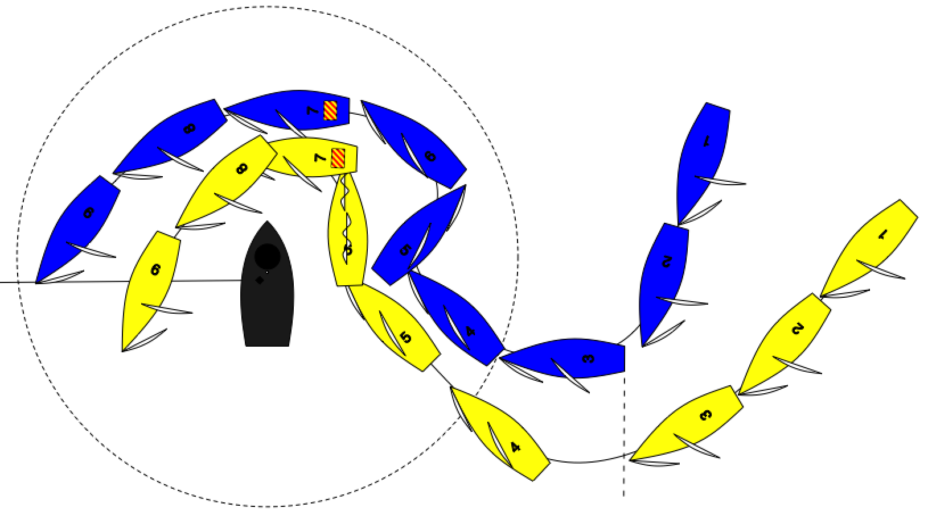
Answer 1
The umpires shall act under rule C5.6 once Blue is no longer taking a penalty on port tack. Signal that Blue has completed her penalty. Penalize Blue and Yellow at the same time. Then signal a second penalty to Yellow.
When the contact happened, Blue was still taking her penalty. Not keeping clear of another boat while taking a penalty does not make the penalty invalid, but it breaks rule 22.2, so because there was a protest, Blue gets one penalty for that breach.
Throughout the incident Blue never leaves the zone, so she is entitled to mark-room all the time. Although Blue is not sailing a proper course while she is taking her penalty, mark-room is still the space she needs to sail her proper course, which is the course she would sail to finish as soon as possible in the absence of Yellow. Yellow fails to give her that space and breaks rule 18.2(a)(2). However Blue is not exonerated for breaking rule 22.2 under rule 21(a) (because rule 21(a) does not include rules in Section D) or 64.1(a) (because Blue was not compelled to break rule 22.2).
Because Yellow gained an advantage by breaking a rule after allowing for a penalty, she also gets an umpire initiated penalty under rule C8.3(a).
Question 2
The situation is the same as in Question 1, except that Blue does not complete her tack onto port tack before tacking back onto starboard tack. What should the call be?
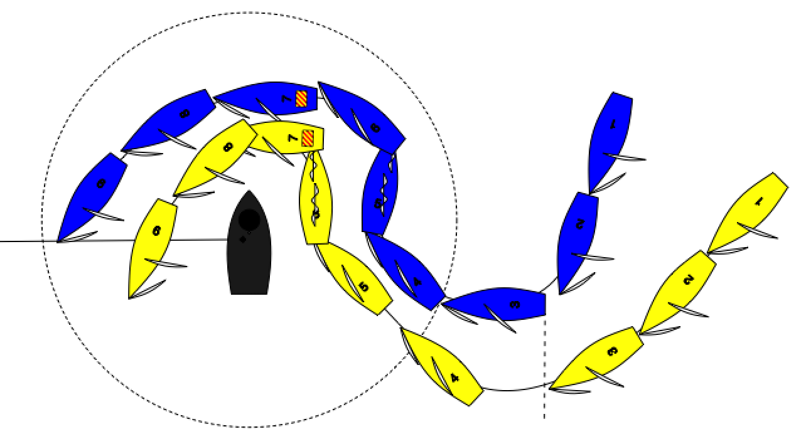
Answer 2
The Umpires shall signal under rule C5.6 once Blue is no longer taking a penalty. Penalize Yellow for not giving mark-room. Remove Blue’s penalty flag as the penalties are now offset. Then signal a second penalty to Yellow.
Blue is no longer taking a penalty after position 5 (see rules C7.2(a)(2) and MR Call N6).
From the time Blue starts luffing back towards starboard tack, she is sailing her proper course to round or pass the mark. Yellow breaks rule 18.2(a)(2) by not giving her mark-room, and Blue is exonerated for her breach of rule 11 under rule 21(a).
Because Yellow gained an advantage by breaking a rule after allowing for a penalty, she also gets an umpire initiated penalty.
MR CALL L1

Rule 32.1(d) Abandoning After the Start
Rule 62 Redress
Rule C9.2 Requests for Redress—Official boat interfering with competing boat
Rule C9.3 Other Proceedings—following action or non-action by umpires

Question

Under what circumstances should a match in progress be abandoned?

Answer

After the preparatory signal a match should be abandoned only when the umpires and race committee are sure that a claim for redress would be upheld were the adversely affected boat to lose the match or for reasons of safety. It is then preferable to abandon the match immediately. The following are examples:

a) a late or incorrect recall signal.
b) serious interference with a competing boat by an umpire or other official boat.

During the preparatory period the match may also be postponed.

A match should not be postponed or abandoned due to an incorrect umpire signal. In this case rule C9.3 applies.

MR CALL L2

Rule 70.1 Appeals to a National Authority
Rule C6.6 Protest Committee Decisions
Rule C9.1 Requests for Redress or Reopening; Appeals; Other Proceedings

Question 1
When there is no international jury appointed and the right to appeal has not been denied under rule 70.5, will umpires assembled to hear a protest or request for redress be a ‘protest committee’ as that term is used in The Racing Rules of Sailing?

Answer 1
Yes.

Question 2
Is the right to appeal a decision by this protest committee under rule 70.1 open for a party to a hearing conducted under rule C6.6?

Answer 2
No. Rule C9.1 denies the right for a party to appeal any decision made under rule C6.6, and further denies the parties the right to request a reopening.

Question 3
Are there any occasions at a match racing event when the protest committee should not conduct the hearing under rule C6.6?

Answer 3
Yes. Rule C6.6 is an abbreviated hearing process designed to allow a match racing event to reach a timely conclusion.

The procedures of rule C6.6 would not be appropriate for protest hearings or requests for redress that are not directly related to the competition, such as protest committee hearings involving entry or eligibility under rule 75 or sailor classification under rule 79. Rule 69 applies to hearings involving allegations of gross misconduct.

The protest committee's decision or its procedures in any hearing not conducted under rule C6.6 is appealable under rule 70.1.

MR CALL L3

Rule 49.1 Crew Positioning

Question 1

One crew member on Yellow holds on to the leeward jib sheet and another one holds on to the main sail sheet when hiking out. Does Yellow break rule 49.1?

Answer 1

No. A working sheet is not a device designed to position the body outboard.

Question 2

Does Yellow (a boat without lifelines) break rule 49.1 when the crew use any of the following to help extend their bodies outboard?

The windward, non working, jib sheet; the barber hauler; the vang control line; the mainsheet traveller line; the backstay control line; the shrouds or other elements of standing rigging

Answer 2

Rule 49.1 does not prohibit competitors from using working sheets or control lines to position their bodies outboard.

Unless specifically prohibited by the event’s sailing instructions (Rules for handling the boats) it is also permissible for competitors to use the shrouds or hand rails to position their bodies outboard.

The use of lazy (non-working) sheets and control lines for hiking breaks rule 49.1.

Question 3

The skipper on Yellow holds a foot under the traveller bridge. Does Yellow break rule 49.1?

Answer 3

No. A traveller bridge is not a device designed to position the body outboard. Using the traveller bridge (or other fixed features of the boat) without modifications that aid projecting the body outboard is permitted.

MR CALL L4

Definitions Keep Clear and Overlap

Question 1

If a person extra to the crew is carried on board a boat, such as an ‘observer’ (umpires' assistant) or a cameraman, should the person or the equipment carried be considered as a part of the boat's ‘hull or equipment in normal position’ for the determination of overlaps or contact between two boats?

Answer 1

No. Such a person is not a part of the boat.

Question 2

Fixed cameras and/or their fixed brackets, placed by or under the direction of the race committee, may project beyond the stern of the boat. Should a camera or its bracket be considered as part of the boat's ‘equipment in normal position’ for the determination of overlaps or contact between two boats?

Answer 2

Yes, when fixed to the boat, cameras or brackets become part of the boat's equipment. Another example would be antennas for radio transmission.

Question 3

Flags carried by boats often project beyond the hull line astern or to leeward of the boats. Should they be considered as part of the boat's ‘equipment in normal position’ for the determination of overlaps or contact between two boats?

Answer 3

No. In match racing flags are not considered to be part of a boat's equipment; the flag staffs are.

MR CALL L5

Rule 42.2(d) Sculling (C2.16)

Question

The boats are approaching the starting line to start.

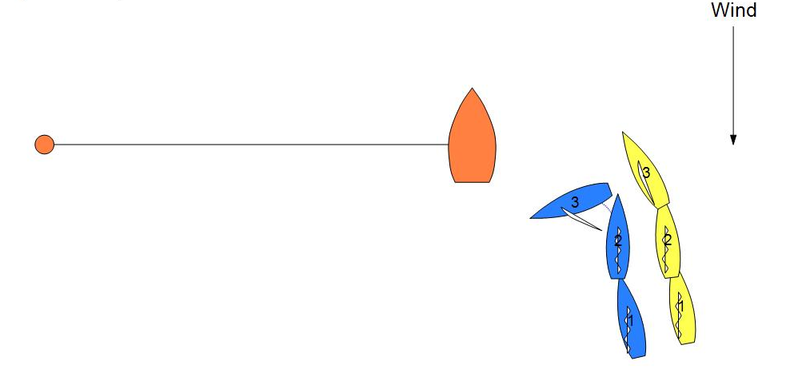
Blue is head to wind and then bears away hard by repeatedly moving her helm until she reaches a a course that is more than ninety degrees from the true wind just before position 3. Should the umpires take any action?
Answer

If the umpires are certain the repeated movement of the helm is to propel Blue forward, they should penalize Blue under rule 42.2(d) as amended by rule C2.16; otherwise they should take no action.

Note that because Appendix C changes rule 42.2(d), World Sailing Rule 42 interpretations with regard to sculling do not apply for match racing.

MR CALL L6

Rule 24.3 When Boats in Different Matches Meet (C2.13)
Rule C6 Protests and Requests for Redress by Boats

Question

Yellow and Blue are in one match with Yellow ahead of Blue. Blue sees an incident between Yellow and Green (a boat in the match ahead) in which Yellow seems to be breaking a rule of Part 2. Green does not Y-flag. What action can Blue take?

Answer

None. Rule C6.1(a) and 6.2(b) prevent Blue from Y-flagging Yellow because she was not involved in the incident.

Rule C6.1(b) prevents Blue from red-flagging Yellow.

MR CALL L7

Rule 24.2 Interfering with another boat
Rule 24.3 When Boats in Different Matches Meet (C2.13)

Question 1
Within the meaning of rule C2.13, if Blue is sailing her proper course, is she permitted to disadvantage Green in a different match?

Answer 1
Yes. When the umpires are satisfied that Blue sailed her proper course, this is consistent with trying to win her own match, by definition, and breaks no rule.

If the umpires are satisfied that the boat's actions were not intended to help her in her own match, but were intended to affect the results of the other match, then Blue breaks rule C2.13. Green may Y-flag under rule C6.1(a).

Question 2
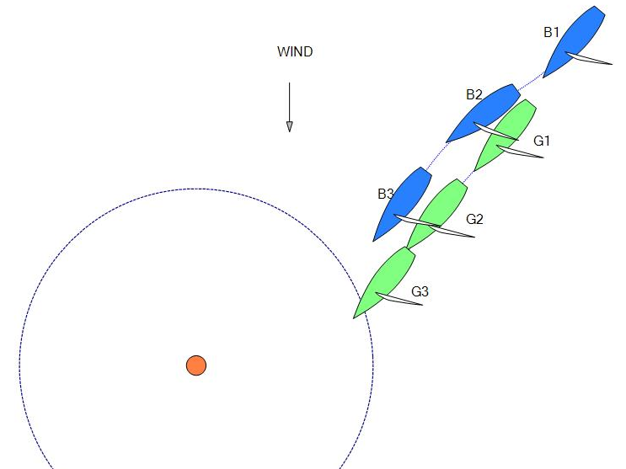
Approaching a leeward mark, Blue is close astern of Green, but they are racing in different matches. Blue luffs to blanket Green, slows her down, and gains an inside overlap. Green must therefore give mark-room to Blue and does so. Has Blue broken rule C2.13?

Answer 2
No. Although Green is definitely disadvantaged by Blue's actions, Blue's actions helped her to round the mark in the shortest possible time, and were therefore ‘consistent with ... trying to win her own match’. See Answer 1.
MR CALL L8

Rule 24.3 When Boats in Different Matches Meet (C2.13)

Question

Yellow and Blue are sailing in one match and Red and Green in another. Green meets Yellow on the course and Green is the right-of-way boat. Is it permissible for Green to change her course so that Yellow has no need to change course to keep clear?

Answer

Yes, provided that the change of course by Green is ‘consistent with complying with a rule or trying to win her own match.’

If Green clearly disadvantaged herself by her course change, then she would have broken rule C2.13.

MR CALL L9

Rule 22.1 Starting Errors
Rule 24.2 Interfering with Another Boat

In all the questions Blue has been signaled correctly as being OCS, but may be unaware that she was OCS and nevertheless continued sailing the course instead of returning and starting correctly.

Question 1

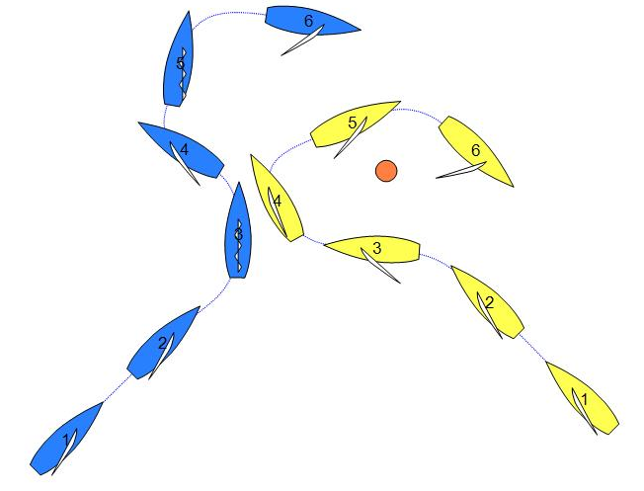
Yellow and Blue are approaching the windward mark. Blue is on port tack and Yellow is on starboard tack. Yellow bears away below her proper course but never to a course more than ninety degrees to the true wind, and passes to leeward of the mark. Blue tacks to keep clear of Yellow. Yellow tacks and rounds the mark well ahead of Blue. There is a Y-flag. What should the call be?
Answer 1

Penalize Yellow.

At position 2 Yellow is in the zone and is right of way, inside boat. Under rule 18.3(b), until she tacks, Yellow is required to sail no farther from the mark than needed to sail her proper course. By bearing away at position 3 Yellow is no longer sailing her proper course.

Question 2

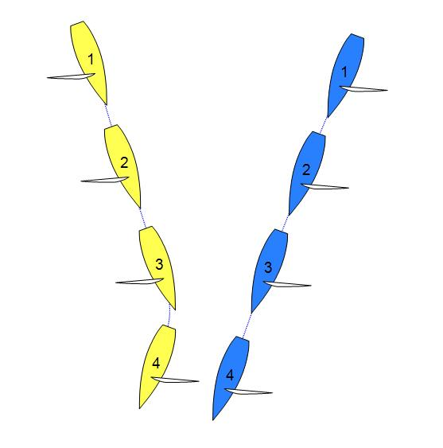
Both boats round the windward mark and bear away towards the leeward mark. Blue on starboard tack approaches Yellow on port tack. Both boats are sailing proper courses. Yellow is forced to gybe away to keep clear of Blue. There is a Y-flag. What should the call be?

Answer 2

Display the green and white flag.

Although Blue has not started correctly and may subsequently be scored OCS, she is sailing the course with full rights and obligations under the rules. Blue is not sailing towards the starting line in order to start, so rule 22.1 does not apply.

Question 3

When should boats be considered to be sailing on the same leg?

Answer 3
Boats should be considered to be sailing on the same leg when the umpires are certain that both boats are sailing to either
- a windward mark,
- a leeward mark, or
- the finish.
This applies when one of them is OCS, and it also applies when they have rounded different marks in order to get on that leg.
MR CALL L10

Rule 16.1 Giving Room
Rule 19 Room to Pass an Obstruction
Rule 21 Penalties and Exoneration

Question

Yellow and Blue, overlapped on port tack, are approaching an obstruction which can be passed on either side.

Blue is sailing to pass to leeward of the obstruction, but from Position 2 Blue luffs quickly to pass to windward of the obstruction. Yellow responds immediately, but is unable to keep clear of Blue. There is contact between them. Both boats protest. What should the call be?
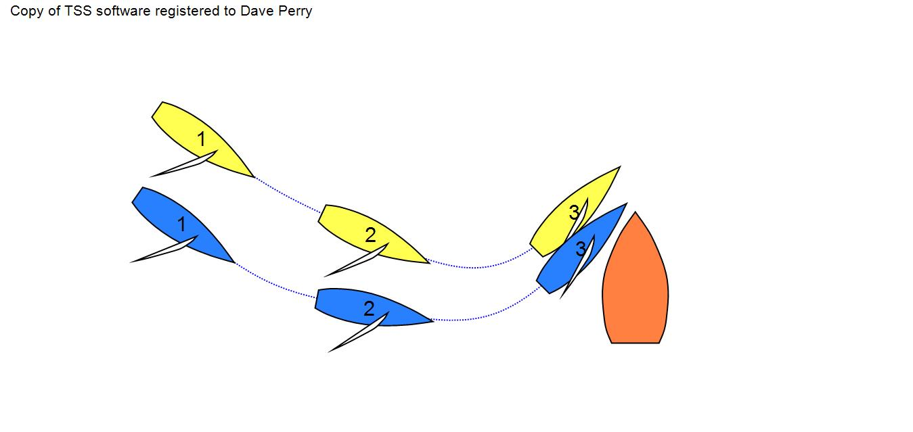
Answer

Penalise Blue.

When Blue changes course to pass to windward of the obstruction she must give Yellow room to keep clear under rule 16.1. Blue fails to do so and breaks rule 16.1.

As a result of Blue breaking rule 16.1, Yellow breaks rules 11 and 19.2(b). Yellow is exonerated for her breach of rule 11 by rule 21(a) because she was sailing within the room to which she was entitled under rule 16.1, and for her breach of rule 19.2(b) under rule 64.1(a) because she was compelled to break that rule by Blue’s breach of rule 16.1.

When a right of way boat on a course to pass on one side of an obstruction
changes course to pass on the other side, she must comply with any applicable
rules of Section A or B.
MR CALL M1

Rule C6.5 Protests and Requests for Redress by Boats: Umpire Decisions
Rule C8.4 Penalties Initiated by Umpires—informing the protest committee
Rule C9.3 Other Proceedings

Question 1

The umpires penalize a boat for breaking a right-of-way rule and signal accordingly. Shortly thereafter the umpires decide they have made an error. May they cancel their signal, by displaying a green and white flag, or by displaying the other boat's signal, or by hailing or some other means of communication?

Answer 1

No. There is no provision in Appendix C to change or amend decisions or signals. When a penalty signal is displayed, the boat is bound by rule C5 to take the appropriate penalty.

Question 2

Would the answer be the same if the umpires displayed a green and white flag when they intended to display a boat's signal?

Answer 2

Yes.

MR CALL M2

Rule C8.3(b) Penalties Initiated by Umpires—deliberately breaking a rule

Question

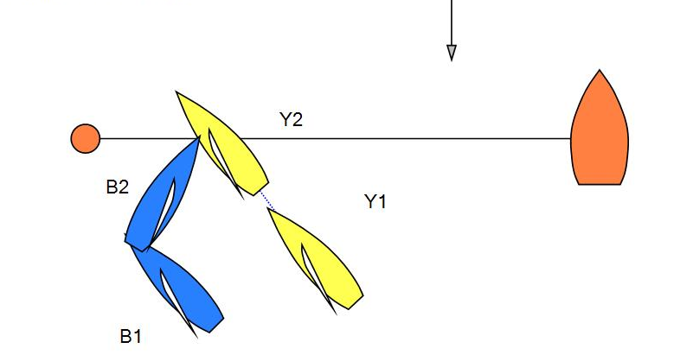
How will the umpires decide if a rule was broken deliberately?

Answer

There is no complete clear-cut answer, but rather a sliding scale of likelihood.
The umpires are likely to conclude that a rule was broken deliberately when:

• the situation has built up for some time rather than occurred instantaneously;
• there is a potentially match-winning tactical gain from breaking the rule;
• the breach does not seem to be a simple misjudgement.

Examples could be:

• breaking a rule to avoid being OCS (windward boat bears down on leeward boat);
• Blue cannot lay the pin and tacks onto port (see diagram above);
• barging at a starting mark;
• denying an inside boat room at the mark.

MR CALL M3

Rule 2 Fair sailing
Rule 20 Room to Tack at an Obstruction (C2.10)
Rule C8.4 Penalties Initiated by Umpires — informing the protest committee

Question 1

Rule C2.10 requires clear and repeated arm signals, in addition to hails. If there is an arm signal but no hail from Yellow, what action should the umpires take

a) if Blue Y-flags?
b) on their own initiative?

Answer 1

- When the umpires are certain that no hail was made, then the signal for room to tack has not been made. (The umpires may be certain there was no hail if they have had no difficulty hearing other calls from a similar position.) For the purpose of the rules of Part 2 they should act as if there has been no signal.

b) The umpires may decide that Yellow has broken rule C8.3(b) or (c) and penalize her. They could also, in an extreme or repeated case, initiate a hearing under rule 2, Fair Sailing.

Question 2

If there is a hail but no arm signal, is the answer the same?

Answer 2

Yes.

MR CALL M4

Rule C8.3(c) Penalties Initiated by Umpires—breach of sportsmanship

Question

After the umpires signal their decision in response to a boat's Y-flag, persons on one of the boats make it clear that they are unhappy with the decision. Should the umpires impose a penalty under rule C8.3(c) for a ‘breach of sportsmanship’?

Answer

This depends on the words, the manner in which they are spoken, and any other related actions of the crew of the boat. If they merely express unhappiness or disappointment, or that in their opinion the decision was wrong, then a penalty is not appropriate. However, if the total effect is to convey that the umpires are incompetent, or are prejudiced against the penalized boat, a penalty may be justified, whether the meaning is directed only at the umpires or also to others nearby. If the meaning is clearly insulting to the umpires, a penalty should be imposed.

MR CALL M5

Rule C6.5 Protests and Requests for Redress by Boats: Umpire Decisions

Question

Immediately following an incident Yellow Y-flags. Before the umpires signal their decision, there is a second incident and Blue Y-flags. How should the umpires signal their decision?

Answer

The umpires should make two separate decision signals, in the order they were signalled by the boats, even when a green and white flag signals the decision for each protest.

MR CALL M6

Rule 60.3(b) Right to Protest (actions by the protest committee)
Rule 62.1(a) Redress
Rule C6.5 Protests and Requests for Redress by Boats: Umpire Decisions
Rule C9 Requests for Redress: Other Proceedings

Question 1

Blue Y-flags, but the umpires make no signal. Both boats finish the race, Blue losing it. May she seek redress under rule 62.1(a) because of the umpires' failure to signal a decision?

Answer 1

No. Rule C9.3 prohibits any ‘proceedings’ because of non-action by umpires. ‘Proceedings’ includes a request for redress.

Question 2

Blue Y-flags, but due to engine failure the umpires do not see the incident. What should they do?

Answer 2

Green and white flag. As the umpires were not in position, their only option is to signal ‘no penalty’. Further, rule C9.1 prohibits the boat from seeking redress, and rule C9.3 prohibits the umpires from initiating redress under rule 60.3.

MR CALL M7

Rule C5.3 Signals by Umpires – red-flag penalty
Rule C6.5(b) Umpire Decisions – red-flag penalty
Rule C7.3(d) Penalty limitations – red-flag penalty
Rule C8.2 Penalties Initiated by Umpires

Question

After starting, Yellow is penalized, and the penalty is signalled with a yellow and a red flag in accordance with rule C5.3 and C6.5(b). After a period of time, the umpires decide that Yellow has not taken the penalty as soon as reasonably possible. What should the umpires do?

Answer

The umpires should penalize Yellow under rule C8.2.

MR CALL M8

Rule 11 On the Same Tack, Overlapped
Rule C7 Penalty System
Rule C8.3(b) Penalties Initiated by Umpires—deliberately breaking a rule

Question

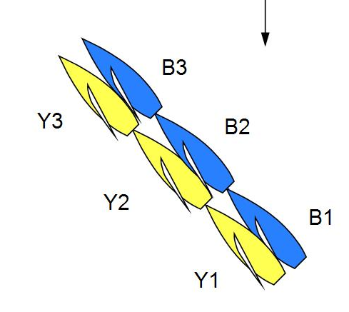
Blue, to windward, fails to keep clear of Yellow to leeward. Yellow protests and Blue is penalized. Some time later Yellow protests again. When should the umpires consider that a rule is broken a second time?

Answer

When the umpires are satisfied that Blue could have taken action to stop breaking the rule after the first penalty is signalled, but fails to do so, they should consider that the rule is broken a second time. The umpires may also decide that the second breach is deliberate and initiate a penalty without any Y-flag being flown.

MR CALL M9

Rule 10 On Opposite Tacks
Rule 20 Room to Tack at an Obstruction
Rule C8.1(b) Penalties Initiated by Umpires—exoneration

Question 1

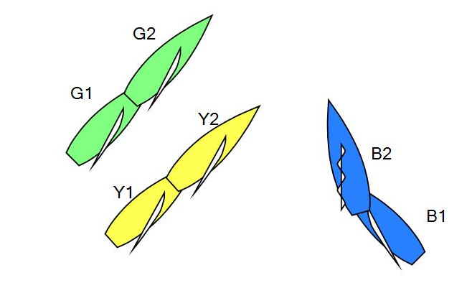
Blue is matched against Yellow and Red against Green. On a windward leg Blue is close-hauled on starboard tack, Yellow and Green are overlapped, both close-hauled on port. Yellow, to leeward of Green, cannot tack and clear Green. Blue and Yellow are on a collision course. Yellow hails and signals for room to tack. Green does not respond, Yellow is unable to tack, Blue is forced to change course to keep clear. Blue and Yellow Y-flag. What should the umpires do?

Answer 1

If the umpires of the match between Blue and Yellow are certain that Green broke rule 20.2(b) they should display a green and white flag indicating that no penalty is imposed on Yellow or Blue. They should advise the umpires for Green's match that Green should be penalized. Rule C8.1(b) permits the umpires to exonerate Yellow without a hearing.

Question 2

If Yellow does not Y-flag, would the answer be different?

Answer 2

No. The umpires response would be the same. The umpires may also consider penalizing Green under rule C8.3(b) or (c).
MR CALL M10

Rule 14 Avoiding Contact
Rule 60.3(b) Right to Protest (by protest committee)
Rule 62.1(b) Redress (physical damage)
Rule C6.1(b) Protest Limitations
Rule C8.3(a) Penalties Initiated by Umpires
Rule C8.4 Penalties Initiated by Umpires

Question

While sailing under spinnakers, there is contact between Yellow and Blue, and Blue receives a small hole in her spinnaker. Yellow is at fault, and is penalized. On a later downwind leg the hole in Blue's spinnaker becomes a major tear. The spinnaker loses all pressure and Yellow is able to pass Blue. What action is available?

Answer

- The umpires could further penalize Yellow as a penalized boat that has ‘gained an advantage by breaking a rule after allowing for a penalty’. Although there has been a delay between the taking of the penalty and the gaining of the advantage, the umpires may still act under rule C8.3(a), if they are satisfied that the spinnaker tear is the result of the original rule breach.

- The umpires could initiate a post-race hearing under rule C8.4 to investigate whether rule 14 was broken.

- In accordance with rule C6.1(b), Blue can red-flag under rule 14, because of damage resulting from contact. The protest committee would need to consider whether the flag was displayed at the first reasonable opportunity after the tear developed.

(d) Blue could request redress under rule 62.1(b) or redress could be considered under rule 60.3(b).

MR CALL M11

Rule C5 Signals by Umpires
Rule C6.5 Protests and Requests for Redress by Boats: Umpire Decisions
Rule C7.2(b) Penalty System: All Penalties

Question 1
Yellow Y-flags. Blue takes a penalty as soon as she sees Yellow's Y-flag and before the umpires signal a decision. What should the call be?

Answer 1
Green and white flag. Rule C7.2(b) allows a boat to take a penalty before being signalled to do so. Rule C5.1 says the green and white flag means ‘No penalty’. Here no penalty is imposed because it was already taken.

Question 2
Would the answer be different if Yellow had an outstanding penalty?

Answer 2
No. The umpires would green and white flag and Yellow’s penalty would remain.

Question 3
Near the end of a windward leg the umpires decide to penalize Blue but delay signalling her until she has rounded the mark. However, she takes the penalty before rounding the mark. Is this allowed?

Answer 3
Yes — see Answer 1. However, under rule C7.3(b) she is not allowed to take any part of a penalty within the zone of a rounding mark.

Question 4
Yellow, with a penalty, breaks a right-of-way rule, is protested by Blue, sees Blue's Y-flag and takes her penalty before being signalled by the umpires. At the time she sees the Y-flag, she is rounding a mark. Should she take the penalty appropriate to the leg she is on or the one appropriate for the time of the umpire's signal?

Answer 4
A boat taking a penalty before it is signalled shall take the penalty appropriate to the leg she is on.

MR CALL M12

Rule 24.1 Interfering with Another Boat (C2.12)
Rule C8.4 Penalties Initiated by Umpires - informing the protest committee

Question

After a race the umpires receive a report from a reliable observer that a boat broke rule C2.12 before her race by interfering with a boat that was racing. May the umpires initiate a hearing to consider penalizing her?

Answer

No. As this concerns a rule of Part 2, the umpires cannot initiate a hearing. Only the boat that was interfered with can take action by displaying a Y-flag at the time of the incident.

MR CALL M13

Rule C9.3 Other proceedings

Question

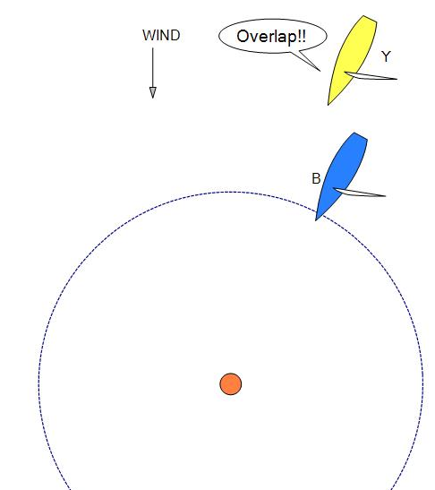
At the end of a downwind leg, just as Blue reaches the zone, Yellow hails ‘Overlap’, but Blue has just seen the wing boat signal the umpires that there was no overlap. May Blue rely on the wing boat's signal and thereby decide to deny room to Yellow?

Answer

No. Competitors who use such signals take a considerable risk. Decisions are made by the umpires, not the wing boats, and an umpires' decision may not be based on the wing boat's signals.

The same principle applies to signals made by on board observers.
MR CALL M14

Rule 18.2 Giving Mark-Room (C2.9)
Rule 21 Exoneration
Rule 31 Touching a Mark (C2.14)
Rule C6.1(a) Protests and Requests for Redress by Boats
Rule C8.2 Penalties Initiated by Umpires

Question

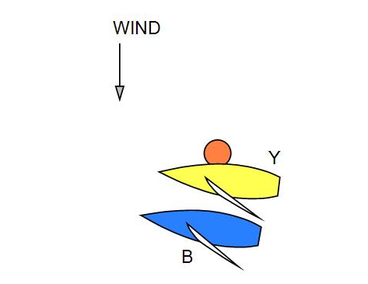
Blue and Yellow are rounding a mark and Yellow touches it with her hull. Neither boat Y-flags. The umpires see Yellow hit the mark, but in their judgement Blue did not give Yellow sufficient room to pass the mark. Should they take any action?

Answer

The umpires should give no signal. Although Blue broke rule 18.2(a) or (b), she cannot be penalized because no boat protested, and rule C8.2 does not permit umpires to initiate a penalty when a boat breaks a rule of Part 2.

Yellow broke rule 31 by touching the mark. However, she is exonerated under rule 21(b).
MR CALL N1

Rule C7.2(a)(1) Penalty System: All Penalties - penalties to a windward mark
Rule C7.2(a)(2) Penalty System: All Penalties - penalties to a leeward mark or the finishing line

Question

The required penalties vary depending upon whether a boat is sailing ‘to a windward mark’ or ‘to a leeward mark’. Because a boat has sailed beyond a mark, or because of a new wind direction, a boat could be sailing free to a mark that was intended to be a windward mark, or sailing close-hauled to a mark that was intended to be a leeward mark. What penalties are then required?

Answer

A boat is to be considered to be sailing to a windward mark or to a leeward mark at all times when sailing to a mark that has been described in the sailing instructions as a windward or leeward mark. The description could be expressed in words, or shown by a diagram indicating wind direction, or by designating marks as either ‘Mark W’ or ‘Mark L’.

In the usual match racing course configuration with two upwind and two downwind legs, a boat sailing the first and third legs is considered to be sailing ‘to a windward mark’, and when sailing the second leg is considered to be sailing ‘to a leeward mark’, irrespective of the boat's heading or the wind direction.

Because a boat may have sailed beyond a mark, or because of a new wind direction, it would be possible for the boat to be sailing close-hauled yet be on ‘a leg of the course to a leeward mark’, or be sailing free on ‘a leg to a windward mark’.

MR CALL N2

Rule 10 On Opposite Tacks
Rule 15 Acquiring Right of Way
Rule 22.2 Taking Penalties
Rule C7 Penalty System

Question

Yellow on starboard and Blue on port are sailing towards each other. When they are about to meet, Yellow is penalized and required to take an immediate penalty (the penalty was either a red flag penalty or her second penalty).
When does the right of way change?

Answer

The right of way does not change until it is clear that Yellow is taking her penalty.

This is when she passes head to wind or the foot of her mainsail crosses the centreline, as appropriate.

Blue will acquire right of way by the action of Yellow and so Blue will not need to give room to Yellow under rule 15.

MR CALL N3

Rule C7 Penalty System

Question 1

Rule C7.3(c) requires a boat with two penalties to take one of them ‘as soon as reasonably possible’. Rule C7.3(d) requires a boat with a red flag penalty to take her penalty ‘as soon as reasonably possible’. How must she comply with this requirement when the proximity of another boat or an obstruction, or both, prevent her from luffing or bearing away to begin her penalty tack or penalty gybe?

Answer 1

She may delay bearing away (luffing, when the penalty is to tack) until there is no likelihood of her making contact with the other boat or the obstruction, however, when the obstruction is continuing or when the other boat obstructs her and by sailing a parallel course continues to obstruct her, she must tack (or gybe) to get clear or she may reduce speed until she is no longer obstructed by the other boat. Should the other boat then tack to prevent her from taking the penalty, she must again tack to further attempt to get clear.

Question 2

A boat with a penalty is penalized again. Part of the penalty would be within two of her hull lengths of a rounding mark were she to take the penalty immediately. What is she required to do before taking a penalty?

Answer 2

She may sail the course she would have sailed without the second penalty until she can take the second penalty without any of the penalty being taken within the zone. She must then take the penalty.

Question 3

A boat with a penalty is penalized again while her spinnaker is set. What is she required to do?

Answer 3

A boat is required to take the penalty as soon as reasonably possible, even though her spinnaker is set. She must lower the spinnaker head below the main boom gooseneck and take her penalty without delay.

MR CALL N4

Rule 47.2 Limitations on Equipment and Crew
Rule C7.2 All Penalties
Rule C7.4 Taking and Completing Penalties
Rule C8.4 Penalties Initiated by Umpires
Definitions Racing

Question 1

A boat with an outstanding penalty is on a windward leg. A crewmember falls overboard. The boat bears away, gybes, luffs head to wind and retrieves the crewmember. Has the boat taken her penalty?

Answer 1

Yes - provided the penalty turn meets the requirements of C7.2 (a).

Question 2

Has the boat broken rule 47.2?

Answer 2
No, provided the return on board is at the approximate place where the crew fell overboard.
MR CALL N5

Rule 24.2 Interfering with another boat
Rule C2.13 Changes to the Rules of Part 2—when boats in different matches meet

Question

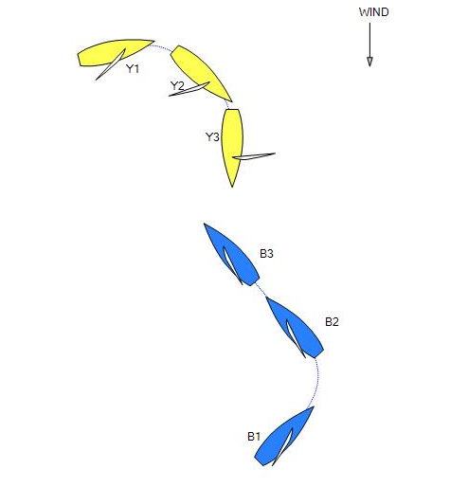
Just after starting, Yellow, on port, bears away and gybes to take a penalty. Blue, also on port, but on a track to leeward of Yellow, tacks to starboard, and as a result is on a collision course with Yellow. Yellow is forced to change course to pass behind Blue before completing her penalty and Y-flags. What should the call be?

Answer

Green and white flag. Rule 24.2 does not apply after the starting signal when a boat is sailing her proper course. Therefore, Blue may interfere with Yellow, provided Blue is sailing a proper course and does not break rule 16.1. She has a choice of proper courses and may therefore choose one that will maximise her interference with Yellow. Sailing on either tack can be a proper course.
MR CALL N6

Rule C5.6 Signals by Umpires - incorrect penalty
Rule C7 Penalty System

Question

Yellow is required to take a tack penalty. May she take it by luffing until she passes head to wind, then turn back to a close-hauled course on her initial tack?
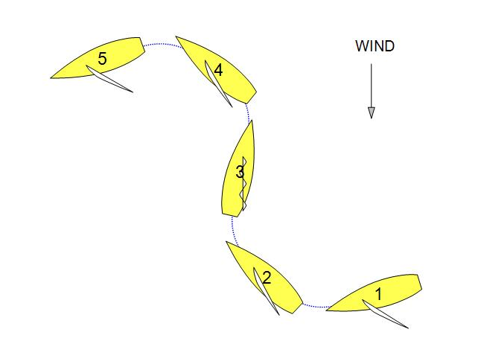
Answer

No, for the purpose of taking a penalty, tacking is to change course from close-hauled on one tack, through head to wind, to close-hauled on the other.

As soon as Yellow passes head to wind rule 13.1 applies and she must keep clear. Although rule C7.4(a) states that a boat with an outstanding penalty that is on a leg to a leeward mark or the finishing line and passes head to wind is taking a penalty, a boat attempting a penalty in the manner described does not comply with rule C7.2(a)(2) and the umpires shall signal that the boat is no longer taking a penalty and that the penalty remains.

MR CALL N7

Rule 22.2 Taking Penalties
Rule C7 Penalty System

Question

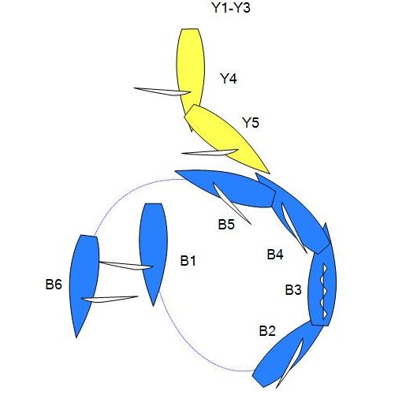
Blue and Yellow are sailing a course that is more than ninety degrees from the true wind on port tack. Blue has an outstanding penalty. She luffs, passes head to wind, and bears away to a close-hauled course on starboard tack. Yellow changes course to avoid a collision before Blue achieves a course that is more than ninety degrees from the true wind. Blue continues to bear away and achieves a course that is more than ninety degrees from the true wind. Both boats Y-flag. What should the call be?

Answer

Signal that Blue has completed a penalty and then penalize Blue again. Blue did comply with rule C7.2(a)(2) and so completed a penalty. However, before returning to a course that is more than ninety degrees from the true wind she broke rule 22.2.
MR CALL N8

Rule C7 Penalty System
Rule C8.3 Penalties Initiated by Umpires - gaining an advantage

Question 1

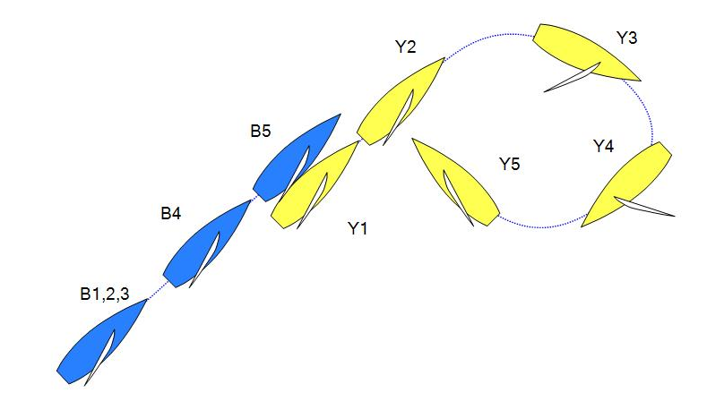
Yellow is penalized before she starts. Later she and Blue both start on port tack, with Yellow to leeward but approximately four hull lengths ahead of Blue. Yellow bears away, gybes, then luffs to close-hauled on starboard tack. Soon afterward rule 10 requires Blue to change course to avoid Yellow. Has Yellow ‘gained an advantage over the other boat’ in the context of rule C8.3(a)?

Answer 1

No. Rule C8.3(a) refers to situations in which the advantage that a boat gains from breaking a rule is greater than the disadvantage she suffers by taking the penalty. Here the advantage that the penalized boat gained as a starboard tack boat after taking her penalty is unrelated to the advantage referred to in rule C8.3(a).

Question 2

The boats are close together on a windward leg and one is penalized. After gybing she sails away on the opposite tack and immediately gains from a major wind-shift. Has she ‘gained an advantage’ from the penalty?

Answer 2

No. See Answer 1.

MR CALL N9

Rule 16.1 Changing Course
Rule 22.2 Taking Penalties
Rule 24.2 Interfering with Another Boat

Question
Blue and Yellow are half way up a windward leg of the course and Blue has an outstanding penalty. Blue bears away to take her penalty.

At position 3, Blue has gybed and is now taking her penalty. Yellow luffs and passes head to wind. Yellow completes her tack at position 4. Yellow then luffs, and before Blue has completed her penalty Blue responds to the luff and keeps clear.

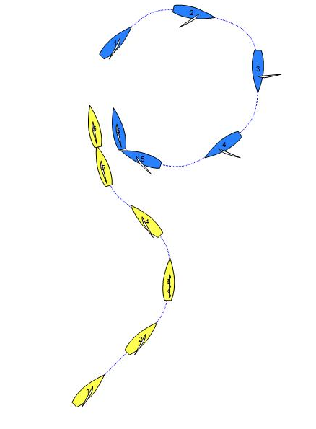
There is a Y flag. What should the call be?
Answer
Penalize Yellow.

From the moment Blue gybes and until she returns to a close-hauled course, she is taking a penalty and must keep clear of Yellow under rule 22.2. Yellow is required to not interfere with Blue while Blue is taking the penalty, unless she is sailing her proper course.

When Yellow luffs after her tack is completed, she is not sailing her proper course and rule 24.2 requires that she does not interfere with Blue who is still taking her penalty. By causing Blue to have to respond to the luff before she had completed her penalty, Yellow did interfere with Blue while Blue was taking a penalty. It does not make any difference whether the interference by Yellow caused the penalty to be completed quicker.
MR CALL N10

Rule 28 Sailing the Course
Rule 90.3(a) Scoring
Rule C6.6 Protest Committee Decisions

Question

As Yellow and Blue approach the leeward mark, the race committee signals a change of position of the windward mark. Both boats round the leeward mark and sail to the original windward mark, round it and finish. Neither boat rounded the new windward mark.

The race committee protests both boats for breaking rule 28.

The protest committee finds that both boats broke rule 28 as neither sailed the course correctly. How should the match be scored?

Answer

Unless there is evidence to the contrary, the protest committee should find that the breach of the rule has had no significant effect on the outcome of the match and decide that the boats should be scored in their finishing positions. See rule C6.6(b)(3).

Note: The race committee should normally only protest when there is either a breach of a sailing instruction or technical rule that cannot be protested by the competitors. See World Sailing Race Management Policies for Match Racing. The race committee should simply score the boats in their finishing positions.
Rules (in call titles)

2: M3
8: B10, C1
10: A2, B7, 12, 16, 19, D2, 4, 5, E1, 8, 11, K4, M9, N2
11: A1, 3, B3, 4, 5, 6, 9, 10, 12, 15, 18, C1, D1, 4, E1, 4, 6, 7, 11, G7, K2, 4, M8
12: B8, 18, D4
13: B6, 11, E1, 6, 8
14: B10, M10
15: B3, 4, 18, D4, E3, G4, N2
16.1: A1, 2, B5, 6, 7, 9, 10, 11, 12, 14, 15, D1, 2, 5, 6, E1, 4, G2, 7, L10, N9
Preamble
Section C: C1,
18.1: E2, 5, 9, 10, J2,
18.2: A3, E1, 2, 3, 4, 5, 6, 8, 9, 10, 11, J1, K2, 4, 5, 6, M14
18.3: E5, 7, 8, J1, 2
19: B14, 15, 16, E11, L10
19.2: B12, 13, 19, C1
20: D3, M3, 9
21: A3, B11, 16, D4, E1, 6, 7, K4, 5, 6, L10, M14
22.2: K2, 6, N2, 7, 9
24: L6, 7, 8, M12, N5, 9
28: K1, N10
31: M14
32.1(e): L1
42.2(d): L5
47.2: N4
49.1: L3
60.3(b): M6, 10
62: L1
62.1(a): M6
62.1(b): M10
70.1: L2
90.3(a): N10

C2.1: See Def. Finish
C2.2: See Def. Mark-Room
C2.3: See Def. Proper Course
C2.5: See RRS 8
C2.6: See RRS 13
C2.9: See RRS 18
C2.10: M3
C2.12: See RRS 24
C2.13: L6, 7, 8, N5
C2.14: See RRS 31
C2.16: See RRS 42.2(d)
C4: B1
C5: K3, M7, 11, N6
C6: L6
C6.1(a): M14
C6.1(b): M10
C6.5: E8, G7, M1, 5, 6, 7, 11
C6.6: L2, N10
C7: M8, N2, 3, 6, 7, 8
C7.2: C2, G7, K3, M11 N1, 4
C7.3: C2, G7, M7
C7.4: K3, 6, N4
C8.1(a): B2
C8.1(b): M9
C8.2: M7, 14
C8.3: E8, G7, K6, M2, 4, 8, 10, N8
C8.4: M1, 3, 10, 12, N4
C9: M6
C9.1: L2
C9.2: L1
C9.3: B2, L1, M1, 13

Definitions

Clear Ahead/
Clear Astern/
Overlap; A4, 5, B8, 16, 19, E11, L4
Finish: A5, K1, 3
Keep Clear: A1, 4, B17, 19, D1, E8, 11, L4
Mark: B14
Mark-Room: E1, 3, 4, 6, 7, 8, K4, 5, 6
Obstructions: B14
Proper Course: E1, 7, 8, J1, 2, K4, 6
Racing: N4 ,
Room: D1, 6, E4, G2

Old Call Names vs New Call Names

GEN 1 General Principles for Umpire Decisions (GenP)
GEN 2 General Principles for Umpire Decisions (GenP)

UMP 1 - B3
UMP 2 - Deleted
UMP 3 - B4,
UMP 4 - B5
UMP 5 - B6
UMP 6 - B12
UMP 7 - B17
UMP 9
Q1&2 - A1
Q3 - Deleted
UMP 10 - B13
UMP 11 - B11
UMP 12 - A2
UMP 13 - C1
UMP 14 - D5
UMP 16 - D2
UMP 17 - Deleted
UMP 18 - A5
UMP 19 - Deleted
UMP 20
Q1 - GenP
Q2 - D6
UMP 21 - A4
UMP 22 - E2
UMP 24 - A3
UMP 26 - L3
UMP 27 - B14
UMP 28 - G4
UMP 29 - D1
UMP 30 - E3
UMP 32 - E4
UMP 33 - G2
UMP 34 - E5
UMP 35 - B7
UMP 36 - J1
UMP 37 - B15
UMP 38 - B8
UMP 39 - Deleted
UMP 40 - Deleted
UMP 41 - J2
UMP 42 - E6
UMP 43 - Deleted
UMP 44 - B18
UMP 45 - Deleted
UMP 46 - B16
UMP 47 - D4
UMP 48 - E9
UMP 49 - B10

MR 1 - B1
MR 2 - B2
MR 3 - C2
MR 4
Q1 - N5
Q2&3 - L7
MR 6 - K1
MR 7 - M10
MR 8 - N6
MR 10 - M14
MR 11 - M13
MR 12 - N2
MR 13 - M4
MR 14 - M5
MR 15 - M6
MR 16 - N3
MR 17 - M11
MR 18 - M12
MR 19 - M1
MR 21 - L4
MR 22 - L8
MR 23 - L6
MR 24 - M3
MR 25 - M9
MR 27 - L1
MR 28 - N7
MR 29 - K3
MR 30 - M8
MR 31 - M2
MR 32 - N1
MR 33 - N8
MR 34 - Deleted
MR 35 - Deleted
MR 36 - M7
MR 37 - K2
MR 38 - D3
MR 39 - G7
MR 40 - K4
MR 41 - E1
MR 42 - B9
MR 43 - Deleted
MR 44 - L1
MR 45 - N4
MR 46 - L5
MR 47 - Deleted

